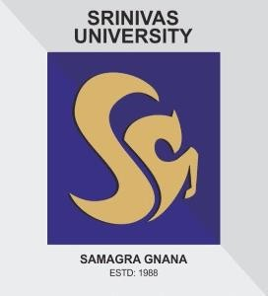
IQAC: 2020-22
CONSOLIDATED REPORT

-- Karnataka State--
CREATING INNOVATORS

SRINIVAS UNIVERSITY
SRINIVAS CAMPUS MUKKA, MANGALORE – 575 001
KARNATAKA STATE – INDIA
www.srinivasuniversity.edu.in

SRINIVAS UNIVERSITY

INTERNAL QUALITY ASSURANCE CELL (IQAC)

The University strongly believes in creating and sustaining excellence in the teaching-learning- evaluation process through innovations and reforms. Accordingly, the IQAC has been established as a permanent and effective mechanism to address all aspects of quality on a day-to-day basis and ensure a culture of quality in the University. It oversees, plan, and monitor the Quality Assurance and Quality Enhancement activities of the University. The IQAC complies with the terms and policy of the University Grants Commission.

Vision
To be a trendsetter among universities and build students who emerge as leaders with competence, conscience, and compassion by empowering them with sound education and high standards of ethical and professional behavior enabling them to build and promote a more humane, just, and sustainable world for the future generation.
Mission
Our mission is to provide an exceptional learning environment where students can develop and enhance their leadership and teamwork skills, creative and intellectual powers, and passion for learning by providing an uncompromising standard of excellence in teaching; embodying the spirit of excellence to educate the citizen- leaders of society with distinction.

Objectives and Functions of IQAC

The Primary aims of IQAC
The following are the aims set by the IQAC;
- Identify, develop, and offer innovative, demand-oriented, futuristic courses in UG, and PG programmes to the students.
- To make progressive innovations in the examination & evaluation system
- To increase the number of research projects/ collaborative activities of the University with various institutions and universities across the country and the globe. Faculty members should be encouraged to submit research projects to different funding agencies.
- To explore the possibility of obtaining access to the libraries of premier higher educational institutions for students and faculty members.
- Monitor and re-enforce the progress of the Training and Placement Cell through increased student training and development programmes.
- Prepare students to appear and qualify for NET/SLET and GATE examinations. Organize more conferences and workshops at the National & International levels.
- Focus on collaboration with national and international universities as well as various industries for curriculum development and knowledge/research partnership.

The Specific Objectives of the IQAC at Srinivas University
- To organize Need-Based capacity building programmes for the students, research Scholars, and the faculties.
- To increase quality awareness as well as develop ongoing quality assessment strategies.
- To promote best practices in the maintenance and enhancement of the quality culture of the university.
- To inculcate the culture of Research and publications in ISSN journals among students, Research Scholars, and the faculties.
- To promote stakeholder involvement in the process of quality assurance and quality culture at Srinivas University.

Functions Performed by the IQAC
- Strategic Planning Forums development of the University.
- The quality benchmarks/parameters for various academic activities of the university.
- Generating the learner-centric environment for quality education and faculty maturation to adopt the required knowledge and technology for participatory teaching and learning process;
- To prepare 360-degree feedback responses from students, parents, faculties, management, Alumni, and the stakeholders on quality and service of the University.
- Consolidating the information on various quality parameters of higher education and preparing the report of IQAC.
- Organization of National and International level workshops, and seminars on Higher education and research.
- Document the quality-improved activities time-to-time to assess the progress.
- Development of quality-related activities, SWAC analysis, and the best practices of the university.
- Conduct an Annual Academic audit and try to improve the quality.

The IQAC members for 2020-22 are as follows;

Composition of the IQAC:
The College has a fully functional Internal Quality Assurance Cell (IQAC) to continuously improve quality as ‘enhancement’ and sustain the good work of the institution. IQAC will facilitate the process of internalization of the quality and play a catalytic role in the performance improvement of the institution. The IQAC creates internal awareness of quality issues and also establishes credibility for external quality evaluation.
The College has a written mission statement or set of objectives that respects the autonomy, identity, and integrity of the stakeholders. The IQAC members for 2019-21 are as follows;

Sl. No. | Name | Designation
 | Dr. Sri. Srinivas Rao | Pro-Chancellor, Srinivas University
 | Dr. P. S. Aithal | Vice Chancellor, Srinivas University
 | Dr. Anil Kumar, Registrar, Srinivas University | Chairman
 | Dr. Laveena D’Mello. (Professor, College of Social Sciences and Humanities) | Director
 | Dr. S. Rajasekar (Dean, College of Physiotherapy | Members
 | Dr. Praveen B. M.(Co-ordinator of Research, SU) | Members
 | Prof. K. R. Kamath (Former Dean, Srinivas Institute of Technology, Mangalore) | Members
 | Dr. Jayashree K. (Dean, College of Education) | Members
 | Prof. Swaminathan S. (Dean, College of Hotel Management) | Members
 | Prof. Subramanya Bhat (Dean, College of Computer Science) | Members
 | Prof. Pavitra Kumari (Dean, College of Management and Commerce | Members
 | Mrs. Rajalaxmi | Senior Administrative Officers
 | Prof. Sonia Ajay | Alumni Representatives
 | Prof. Pradeep M.D, SIMS | Alumni Representatives
 | Dr. Krishna Prasad | Alumni Representatives
 | Prof. Keerthana Raj | Faculty Members
 | Prof. Vasudeva | One/two nominees from Employers /Industrialists/stakeholders
 | Mr. Ranjan | Student Male representatives
 | Ms. Krathika | Student female representative
 | Prof. K. V. M. Varambally (Former Director, School of Management, Manipal University, Manipal) | Local representatives

Composition of AAA committee members

List of Academic Audit Team

Sl. No. | Name and Address
Dr. Anil Kumar (Registrar)
Srinivas University, Srinivas Campus
Srinivas Nagar, Mukka, Mangaluru- 574146

2. | Dr. Srinivas Mayya (Registrar Evaluation)  Srinivas University, Srinivas Campus  Srinivas Nagar, Mukka, Mangaluru- 574146
3. | Dr. Sreeprakash, (Professor, CET)  Srinivas University, Srinivas Campus  Srinivas Nagar, Mukka, Mangaluru- 574146
4. | Dr. Praveen B. M. (Research Director)  Srinivas University, Srinivas Campus  Srinivas Nagar, Mukka, Mangaluru- 574146
5. | Dr. Thomas Pinto (Dean, Srinivas Institute of Technology)  Srinivas University, Srinivas Campus  Srinivas Nagar, Mukka, Mangaluru- 574146
6. | Prof. A. R. Shabaraya (Director)  Srinivas College of Pharmacy  Valachil.
7. | Prof. Swaminathan S. (Dean, College of Hotel Management)  Srinivas University, City Campus,  Pandeshwar, Mangaluru- 575001
8. | Prof. Subramanya Bhat (Dean, College of Computer Science)  Srinivas University, City Campus,  Pandeshwar, Mangaluru- 575001
9. | Prof. Keerthana Raj (Dean, College of Management and Commerce  Srinivas University, City Campus,  Pandeshwar, Mangaluru- 575001
10 | Dr. Jayashree K. (Dean, College of Education)  Srinivas University, City Campus,  Pandeshwar, Mangaluru- 575001
11. | Dr. S. Rajasekar (Dean, College of Physiotherapy)  Srinivas University, City Campus,  Pandeshwar, Mangaluru- 575001

SECTION B
FACULTY DEVELOPMENT PROGRAMME – 2019, 2020, &2021

Year | Faculty(teaching/non-teaching) | Programme | No. of participants
2019 | Teaching Faculty | Importance of Patenting and copyrights – basic information | 60
 | Teaching Faculty | Plagiarism and Browser extension for enhanced digital skill. | 50
 | Non-teaching Faculty | Maintenance of University Registers & Records | 30
2020 | Teaching Faculty | Workshop to prepare the blueprint of the question paper | 50
 | Teaching Faculty | Introduction to Competency-based teaching and learning process at the higher education level | 50
 | Teaching Faculty | Platform to be used for online classes | 60
 | Non-Teaching | Quality service and Skill Management | 30
2021 | Teaching Faculty | Introduction to Competency-based teaching and learning process at higher education level | 50
 | Teaching Faculty | SU faculty responsibilities & how to increase annual performance indicator (API) scores | 60
 | Teaching Faculty | SU faculty responsibilities & how to increase annual performance indicator (API) scores | 60
 | Non-teaching | SU Student Quality Improvement Programme | 30
 | Teaching Faculty | Faculty Responsibilities of Srinivas University to provide student centered Education | 50
 | Teaching | IQAC (Internal Quality Assurance Cell) Documentation- Guidance to maintain the course files | 60
 | Non-Teaching | Quality Service & Skill Management | 35
2022 | Teaching | Teaching Faculty Responsibilities | 50
 | Non-Teaching | Empowering the Managerial Skills | 45
SECTION C

Conferences and Workshops conducted- 2019

Year | College Name | Title of the IQAC conference/ workshop
2019 | Institute of Computer Science & Information Science | National Conference on Recent Advances In Technology, Innovations in IT, Management, Education and Social Sciences
 |  | National conference on the theme Invention in ICT & Its Impact on Management, Social Science and Education in Association with Raiganj University, West Bengal
 | Institute of Social Sciences and Humanities | National conference on “Research in Higher Education, Learning & Administration”
 |  | National conference on “Social Entrepreneurship and innovations in IT Management and Social Sciences and Innovate techniques of school education and teachers education for 21stCentury.
 |  | Mobility Stability and Sustainability challenges for social scienes, management it and Education
 | Institute of Physiotherapy | “57th IAP pre conference workshop on K – CAT”
 |  | Physiotherapy screening camp at Udupi power cooperation limited
 |  | National level conference on shoulder symposium
 |  | Workshop on BLS Basic life Support AHA guidelines 2015
 |  | Free physiotherapy screening camp at Casagaya church premises
 |  | National-level conference on Neurotrauma and Rehabilitation
 | Institute of Education | Importance of Patenting and copyrights – basic information
 |  | Plagiarism and Browser extension for enhanced digital skill.
 |  | Maintenance of University Registers & Records
 | College of Hotel Management | “Developing Indian Tourism: Innovative Ideas and Practices”
 |  | ” Challenges Faced by Budding Job Seekers In The Industrial Frame Work: Practices And Remedies”
 |  | A Bakery Workshop On "Baking Buddies"
 |  | Work Shop on Housekeeping
 | College of Management and commerce | Advances in Management, IT, Education, Social Sciences – MANEGMA 2019
 |  | International Conference on Emerging Trends in Management, Information Technology & Education
 |  | Innovation Practices In Banking, Management, IT, Education And Social Sciences
2020 | Institute of Computer Science & Information Science | Five Days Research Methodology Webinar Series by Dr. P. S. Aithal, Dr. Praveen B. M., Prof. Shashidhar Kotian M., Dr. Narayana Kayarkatte, and Dr. Krishna Prasad K of Srinivas University
 |  | Four days International Virtual Webinar Series on Research Trends in Computer and Information Science by 20 Eminent Speakers
 |  | One Day Virtual International Conference on Computational Physics in Emerging Technologies
 |  | Webinar on The Benefits of IEEE-An Academic Perspective by Dr R Thamarai Selvi, Head, Department of Computer Applications and Associate Dean of Research, Bishop Heber College (Autonomous) Tiruchirappalli
 |  | Webinar on IEEE Benefits to Research Community by Dr. Ved Prakash Mishra, Program Leader and Associate Professor, Computer Science & Engineering and IEEE Student Branch Counselor, Amity University, Dubai, UAE
 |  | Webinar on Healthtech – Current Trends and Challenges by Mr. Shiva Kumar Hosangadi, Director, Software Engineering, GE Healthcare, Bengaluru
 |  | Webinar on Intellectual Property Rights & Patent Analysis by Dr. P. S. Aithal, Vice-Chancellor, Srinivas University
 |  | Workshop on Documentation Using Latex by Mr. Md Abdul Raheman, Assistant Professor, Gd II, Dept of Electrical and Electronic Engineering, NMAMIT Nitte
 |  | Certificate Course on Simulation Modeling in Computer Science Research
 |  | National Level Virtual Conference on Future Technologies of IT, Management, Education and Social Sciences
 |  | Webinar on Copyright – An Intellectual’s Property by Dr. Ganesha H. R., CEO- Consulting, Gramss Retail, Bengaluru and Post-Doctoral Fellow, College of Management and Commerce, Srinivas University Manguluru
 | Institute of Social Sciences and Humanities | 1day national level Virtual conference on “Web Higher Education in Social sciences, IT and Management”
 | Institute of Physiotherapy | Webinar on Breathing pattern disorders – Musculoskeletal Perspective
 |  | Webinar on Pulmonary Hygiene for Covid – 19 cases – A Physio Perspective
 |  | Webinar on Dizziness Dilemma – Diagnosis and Clinical decision
 |  | Webinar on Oro motor care for differently abled children
 |  | Webinar on Introduction to Dynamic Neuromuscular Stabilization (DNS) and its implementation in Sports related relational spinal injuries
 |  | Webinar on Muscle Imbalance Paradigm in Human Kinetics – the Janda Approach
 |  | Webinar on Introduction to Facial Manipulation and its implications in lower back
 |  | E-conference in embedding a Rehabilitation approach in Oncology care
 | Institute of Education | Workshop to prepare the blueprint of the question paper
 |  | Introduction to Competency-based teaching and learning process at higher education level
 |  | Platform to be used for online classes
 |  | Quality service and Skill Management
 | College of Hotel Management | “Rural And Urban Tourism in India: Current Trends And Issues”
 | College of Management and Commerce | Uncertainties & Challenges in the Uncertain Times – MANEGMA 2020
2021 | Institute of Management and Commerce | Resilience, Innovation & Reinvention – Coping with Turbulent Times – Manegma 2021
 |  | Emergence in Commerce, Business, Management and Information Technology (ICONECBIT – 2021)
 |  | Academic Research and Innovation in Management, Information Technology, Social Science& Education (ICARI-2021)
 | Institute of Computer Science & Information Science | 7 days Virtual Workshop on Research and Publication Ethics by by Dr. P. S. Aithal, Dr. Praveen B. M., Prof. Shashidhar Kotian M., and Dr. Krishna Prasad K of Srinivas University
 |  | 'Four Day Virtual Workshop on How to do Good Research?' by Prof N Sundararajan, Retired Professor, School of Electrical and Electronic Engineering, Nanyang Technological University Singapore and Dr B S Mahanand, Raman Research Fellow (Harvard), Associate Professor, Dept of Information Science and Engineering, SJCE, Mysuru. IEEE Srinivas University Student Branch organized this workshop
 |  | Webinar on Unveiling the challenges while pursuing Doctoral studies for a smooth work-life balance by Dr (Prof) Kathyayini BV, Professor & Principal, NIMHANS College of Nursing, Bangalore
 |  | Webinar on Transactional Analysis and related Research by Dr. (Prof.) Rashmi Kodikal, Chief Editor, Journal of Applied Management & Advanced Research from Apex Publication House, Mumbai
 |  | National Level Webinar on Block Chain, Smart Contract and Its Applications by Dr. Arun Kumar B. R., Professor, Computer Science & Engineering, BMSIT&M, Bangalore
 |  | International Conference On ICT, Cyber Security & Forensic
 |  | National Level Webinar on Tips for Writing an Effective Research Paper by Dr. Rama Satish K V, Professor, RNSIT, Bangalore
 |  | National Level Webinar on Technology Development and Entrepreneurship by Dr. Y. Shrihari Upadhyaya, CEO, Manipal Universal Technology Business Incubator, Manipal
 |  | A Workshop on Research Step 1,2, 3 by Prof. M. S. Kotian and Dr. Sheethal Ullal, Professor & Head, Department of Pharmacology, KMC, Mangalore
 |  | A National Level Webinar on Computer Ethics and Social Value by Dr. Jagadeesha S. N., Retd-HOD, Department of Computer Science & Engineering, JNNCE, PESITM Shimoga
 |  | International Conference on Emerging Trends in Computer Science & Technology
 |  | Technology Trends and Use Cases by Mr Shridhara Bhat, Senior Director, Cognizant Technology Solutions, Hinjawadi, Pune, Maharashtra. Organized by Srinivas University IEEE Student Branch
 |  | Five Days Workshop on Cyber Security and Ethical Hacking by IEEE Srinivas University Student Branch
 |  | Virtual International Conference on the topic “Artificial Intelligence and Quantum computing”
 | Institute of Social Sciences and Humanities | National Level Conference on Reform, Perform and Transform challenges and Opportunities in the field of Social Sciences, Management, Information science, and law and education.
 |  | National level Virtual conference on “Mental health in an Unequal World- Challenges in the field of Social Sciences, IT and Management
 |  | National level Virtual conference on “Emerging Horizon in Skill Development”
 | Institute of Physiotherapy | E-conference on “Earlier the Better”- Recent trends in early identification and Physiotherapy management of the high-risk mother and baby
 |  | One day national level CME titled “evidence-informed practice in mechanical neck pain and headache-an update”
 |  | Dental postural awareness program
 |  | Workshop on research methods and biostatistics for a physiotherapist
 |  | Diabetic neuropathy camp
 |  | Geriatric activity camp
 |  | National level Geriocon – conference on Holistic approach
 |  | Seminar on Blood flow restriction training (BFRT)
 |  | Seminar on Introduction to dynamic neuromuscular stabilization
 |  | Seminar Pain Science
 |  | CME on Osteoarthritis
 |  | Stecco’s Facial Manipulation Level – 1 course
 | Institute of Education | Introduction to Competency-based teaching and learning process at higher education level
 |  | SU faculty responsibilities & how to increase annual performance indicator (API) scores
 |  | SU faculty responsibilities & how to increase annual performance indicator (API) scores
 |  | SU Student Quality Improvement Programme
 |  | Faculty Responsibilities of Srinivas University to provide student centered Education
 |  | IQAC (Internal Quality Assurance Cell) Documentation- Guidance to maintain the course files
 |  | Quality Service & Skill Management
 |  | Teaching Faculty Responsibilities
 |  | Empowering the Managerial Skills
 | College of Hotel Management | “Changing Trends and Challenges Faced by Hospitality, Tourism, Education And Management In Current Pandemic”
 |  | A Workshop On "Bed-Making Skills"
 |  | A Workshop On " Flower Arrangement"
 |  | A Bakery Workshop On"Career Awareness"
 |  | 2021 A Workshop On "Ice Carving"
 |  | Webinar On Hospitality Entrepreneurship Development
 |  | An Online Webinar on Basics of Bartending

DETAILS OF THE CONFERENCES CONDUCTED

Virtual Workshop on Research and Publication Ethics

Srinivas University Research Council organized a week workshop on the topic "Workshop on Research & Publication Ethics" for the research scholars of Srinivas University from 08-2-21 to 15-2-21. The webinar was inaugurated by Dr. P. S. Aithal, Vice-Chancellor, Srinivas University. Dr. Praveen B. M., Director, Research and Innovation Council, Srinivas University explained about 7 days Webinar. There was a total of 10 sessions of 1 ½ hour duration hosted by Research Council of Srinivas University. Around 250 research scholars from computer science, Management, Social Sciences, and Allied Health Sciences took part in this workshop. The workshop comprised various research related topics. This workshop demonstrated with mandatory requirements as per UGC, Ethics & Philosophy, Information about various open access publications & Databases, Data collection Srinivas University Research Council organized a week workshop on the topic "Workshop on Research & Publication Ethics" for the research scholars of Srinivas University from 08-2-21 to 15-2-21. Around 250 research scholars from computer science, Management and Social Sciences took part in this workshop. The workshop comprised various research related topics. This workshop demonstrated with mandatory requirements as per UGC, Ethics & Philosophy, Information about various open access publications & Databases, Data collection, Best practice in scholarly publishing, Research Metrics etc were the topics covered. Dr. P. S. Aithal, Vice Chancellor, Srinivas University, Mangaluru, Dr. Praveen B M, Director, Research & Innovation Council, Srinivas University, Mangaluru, Dr. Krishna Prasad K, Associate Professor & Director-CRC, College of Computer Science & Information Science Srinivas University, Mangaluru, were Three Resource Persons for the Seven days Research Methodology webinar. The Webinar Series received an overwhelming response from various parts of India and 500 participants registered.

Virtual Webinar on How creative are you?
College of Computer Science and Information Science, Srinivas University organized activity based talk on “How creative are you?” on 30th January 2021. Dr. (Prof.) D.H.Rao, Former Dean (Academic) of V.T.U. Belagavi, Karnataka was the resource person. This activity helped researchers to find out their creative quotient. He explained that knowledge is the basis for which creativity and innovation can develop. He guided students to take a break from the problem statement and let their mind wander and open their mind. This workshop helped researcher to rewrite the problem in a completely different way. 165 research scholars from various universities participated in this workshop. Dr.P.S.Aithal, Vice chancellor of the university and Dean of CCIS, Prof. Sridhar Acharya was present. Dr.Nethravathi P.S, Professor of CCIS was the convener for this program and welcomed the speaker. Dr.Krishna Prasad K, Associate Professor, CCIS gave the vote of thanks.

Virtual Webinar on How to do Good Research?
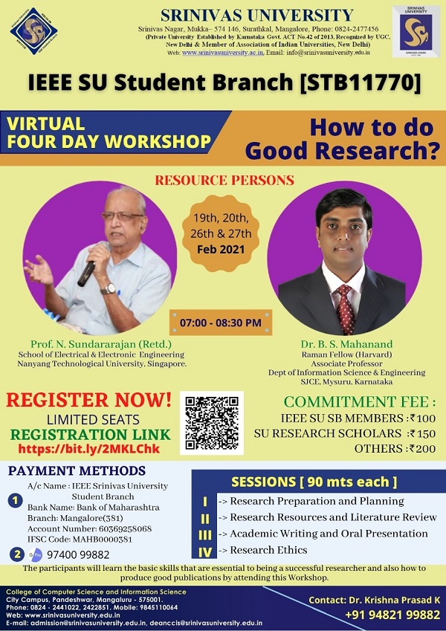
College of Computer Science and Information Science, Srinivas University organized a virtual four day workshop on “How to do Good Research?”, on 19th, 20th, 26th and 27th of February 2921. Dr.(Prof) N.Sundararajan (Retd), School of Electrical & Electronic Engineering, Nanyang Technological University, Singapore and Dr.B.S.Mahanand, Raman Fellow (Harvard), Associate Professor, Department of Information Science & Engineering S.J.C.E., Mysuru, were the resource person. Four important sessions were included on the topics, research preparation and planning, research resources and literature review, academic writing and oral presentation and research ethics. The scholars learnt to how to identify their topic, how to do a preliminary each for information, how can they get and search material. Also identified evaluation sources, how to cite their papers etc. 205 research scholars from various universities participated in this workshop. Dr.P.S.Aithal, Vice chancellor of the university and Dean of CCIS, Prof. Sridhar Acharya were present. Dr.Nethravathi P.S, Professor of CCIS was the convener for this program and welcomed the speaker. Dr.Krishna Prasad K, Associate Professor, CCIS gave the vote of thanks.

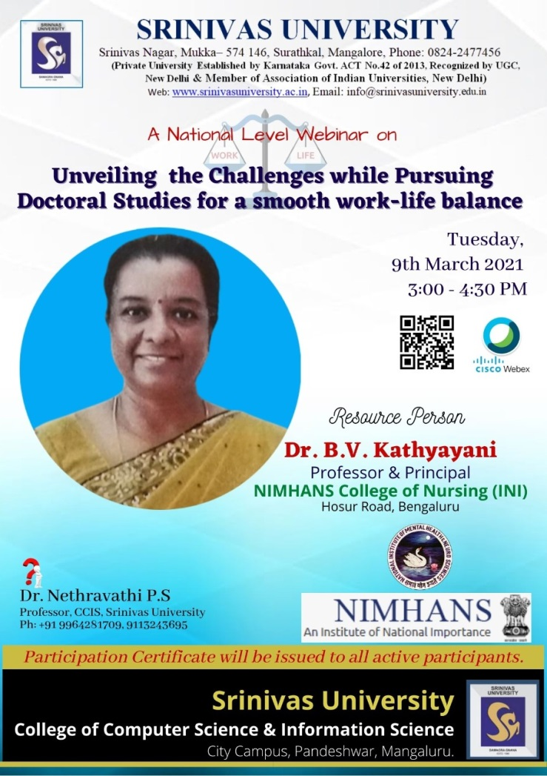
Virtual Webinar on Unveiling the challenges while pursuing doctoral studies for a smooth work-life balance

College of Computer Science and Information Science, Srinivas University organized a National Webinar on the topic “Unveiling the challenges while pursuing doctoral studies for a smooth work-life balance” on March 9th, 2021. Dr.(Prof.) Kathyayani B.V, Professor and Principal, NIMHANS College of Nursing, Bangalore was the resource person. The speaker address research scholars on the problems they face regarding work-family balance due to societal, cultural, family, and gender norms. The speaker mentioned in her speech that work-family issues of working women and challenges faced by working people and strategies adopted by them to manage work-family obligations. She also said that the flexibility and homeworking, family and spousal support, and organisational support as key driving forces for women's work‐life balance and sustainable management of professional and personal lives, and listing out priorities are useful techniques women adopt to integrate work‐family commitments 102 research scholars from various universities participated in this workshop. Dr.P.S.Aithal, Vice chancellor of the university and Dean of CCIS, Prof. Sridhar Acharya were present on this occasion. Dr.Nethravathi P.S, Professor of CCIS was the convener for this program and welcomed the speaker. Dr.Krishna Prasad K, Associate Professor, CCIS gave the vote of thanks.
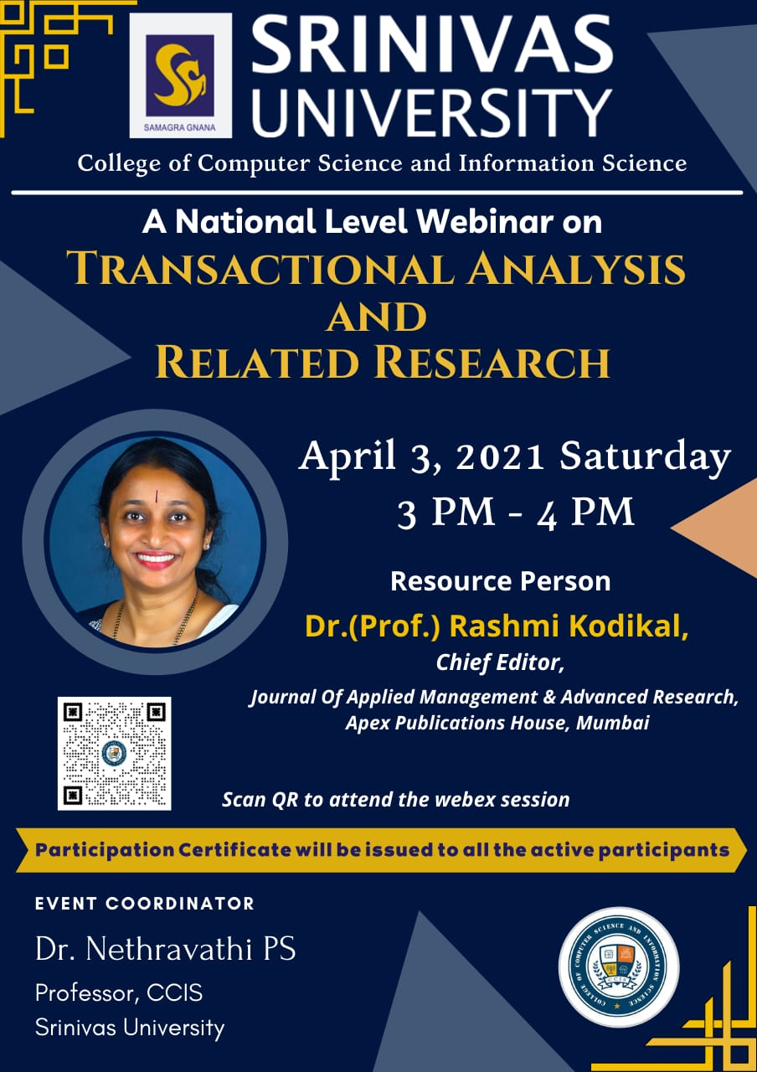
Virtual Webinar on Transactional Analysis and related research

College of Computer Science and Information Science, Srinivas University organized a National Level webinar on the topic “Transactional Analysis and related research” on April 3, 2021. Dr.(Prof) Rashmi Kodikal, Chief Editor, Journal of Applied Management & Advanced Research from Apex Publications House, Mumbai was the resource person. The resource person spoke on how the communication exchanges between people and the parent, adult and child ego states and the interaction between them form the foundation of transactional analysis theory. She mentioned that, these concepts have spread into many areas of therapy, education, and consulting as practiced today. 160 research scholars from various universities participated in this workshop. Dr.P.S.Aithal, Vice chancellor of the university and Dean of CCIS, Prof. Subhramanya Bhat were present on this occasion. Dr.Nethravathi P.S, Professor of CCIS was the convener for this program and welcomed the speaker. Dr.Krishna Prasad K, Associate Professor, CCIS gave the vote of thanks.

Virtual Webinar on Blockchain, Smart Contract and its applications
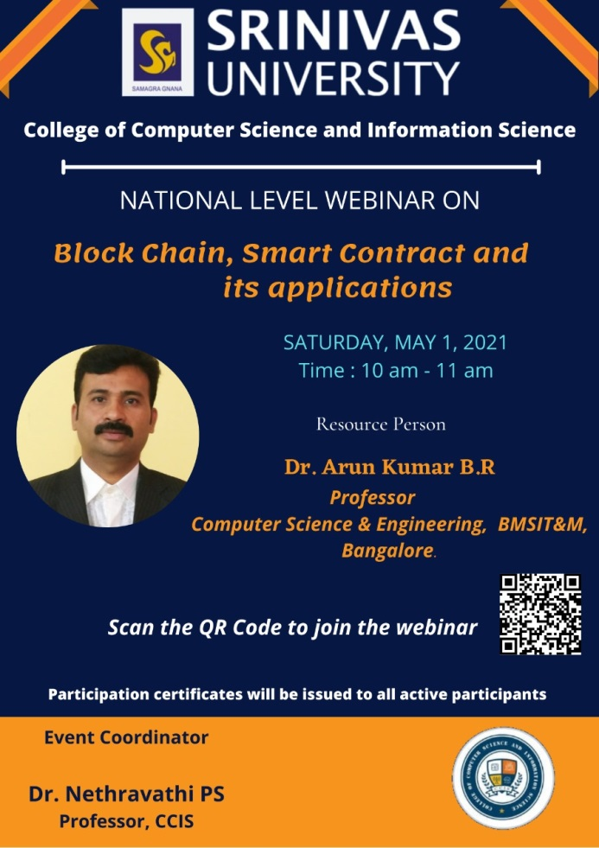
College of Computer Science and Information Science, Srinivas University organized a National Level Webinar on 1st May 2021, on the topic “Blockchain, Smart Contract and its applications”. Dr.Arun Kumar B.R, Professor, Computer Science & Engineering, BMSIT & M, Bangalore was the resource person. In his speech, he discussed about smart contract with real examples. He also explained how the transaction occurs without the need for human. He said, this type of technologies allows the consumer to make a purchase without middleman. Around 175 participants from various places participated in this workshop. Dr.P.S.Aithal, Vice chancellor of the university and Dean of CCIS, Prof. Subhramanya Bhat were present. Dr.Nethravathi P.S, Professor of CCIS was the convener for this program and welcomed the speaker. Dr.Krishna Prasad K, Associate Professor, CCIS gave the vote of thanks.

Srinivas University Conducted International Conference in Association with ICCRD-CUICI Argentina—Sponsored by DataSpace Security Pvt. Ltd. On 17th May 2021

The College of Computer Science and Information Science, Srinivas University, Mangalore has successfully organized an International Conference on ICT, Cyber Security and Forensic (ICONICYSEC-2021), held on 16th and 17th May, 2021. The Two Days International Conference offered the opportunity of participants globally without any registration charges. Importantly the Conference was conducted in Online Mode with Google Meet and Youtube. The Conference was graced by the leadership of Prof. P.S. Aithal (Vice Chancellor, Srinivas University, Mangalore, India) as a General Chair. The Conference has organized in Association with the International Centre for Curriculum & Research Development (ICCRD), which is an unit of CUICI and incorporated in the State of Delaware, USA and approved by the appropriate authorities in Argentina Campus (also worldwide campus & online operations). As an international centre it is also approved by the Board of Quality Standards (BQS)-INQAAHE, Spain at Europe as an international institute of teaching, skill development, research etc.
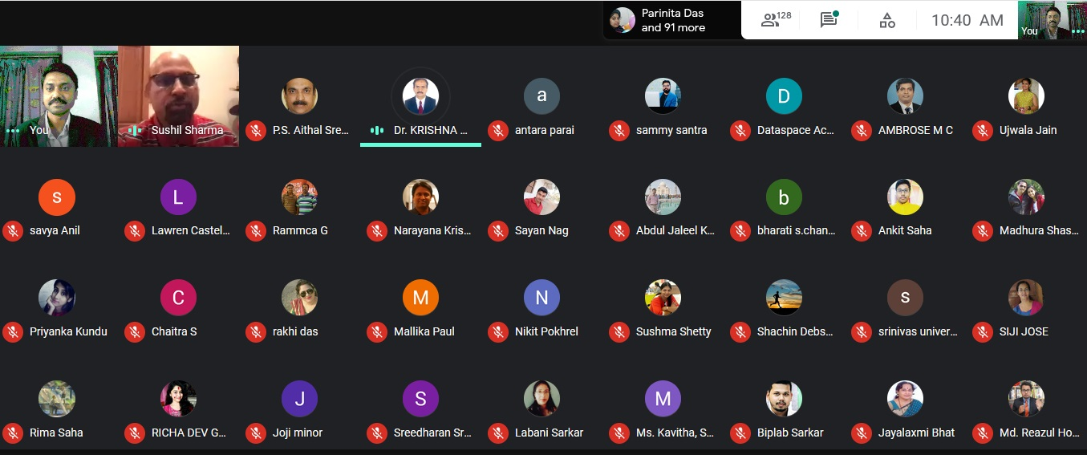
Prof. Bashiru Aremu, President (ICCRD) & Vice Chancellor, Crown University Int. Chartered Inc. (Delaware; USA, Santacruz; Argentina & Worldwide Partnered Campus & Online Operations) acted as a Chief Mentor for this event.
Furthermore, International Conference on ICT, Cyber Security and Forensic (ICONICYSEC-2021) was fully sponsored by the DataSpace Security Pvt. Ltd., which is a Security based Solution Company and also Corporate and Academic Training Providers. The Conference was privileged by six important lectures divided into three category (Keynote Lecture, Invited Lecture and Corporate Trainers. The first speech of the Conference was given by Prof. Sandeep Poddar, Deputy Vice Chancellor (Research & Innovation), Lincoln University College, Malaysia on the topic ‘Digital Education: Contemporary Scenario, Opportunities and Issues’ he addressed many issues in online and digital education including evolution, current trends and issues at large.

Second Keynote Address was given by Prof. (Dr.) Md. Zahir Uddin Arif, on ‘Managing Cyber Security during COVID-19 Pandemic’ Prof. Arif is also a Trustee Member, CUICI Argentina & Professor, Faculty of Business Studies, Jagannath University, Bangladesh. He nicely pointed out how Cyber Security is changing and how to manage many threats etc during current Pandemic. The Third talk of First Day of the International Conference was delivered by an Industry Expert in Cyber Security as an Invited Speaker Shri. Abir Atarthy on Cyber Forensic Tools and Techniques. And presented how many tools in the domain emerged and their role in particular forensic. The first Day was over by vote of thanks of Dr. P.K. Paul. However apart from Srinivas University, CUICI Argentina and DataSpace Security at the first Day Prof. Damodar, Vice Chancellor, Chaitanya Deemed University, Telengana also joined at enlighten the inauguration session. Prof. Soumya Paul,Principal, SMTCK West Bengal, India was also present in this session.
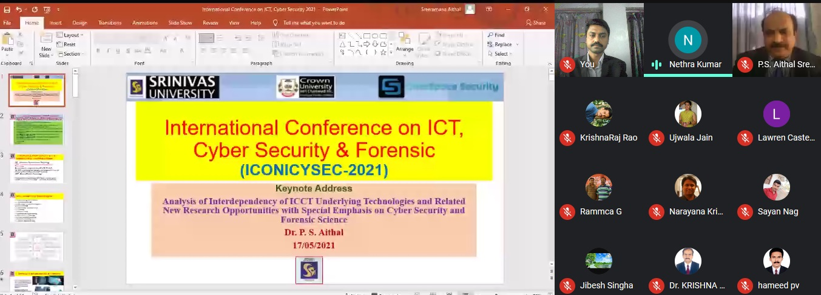
The second day of the Conference was graced by the Three important lectures ranging from Keynote and Industry Talk. Prof. Sushil K. Sharma, Associate Dean (Operations), & Professor (Information Systems) MCB, Ball State University, Indiana, USA delivered his valuable lecture on ‘The Emerging Technologies of the 21st Century and its Impact on the Society’ And he highlighted many technologies which are connected with the society and impacting for the betterment. Another important keynote address was given by Prof. P.S. Aithal who is also the Vice Chancellor of Srinivas University Mangalore, India on ‘Analysis of Interdependency of ICCT Underlying Technologies and Related New Research Opportunities with Special Emphasis on Cyber Security and Forensic Science’ . He highlighted how another important technology ICCT can be fruitful in developing Society with slant to Cyber Security and Forensic. The last lecture was given by Shri. Samiran Santra, who is a CEO and Managing Director, DataSpace Security Pvt. Ltd. on the topic ‘Cyber Security for Everyone’ and his address he practically shown about Cyber Security Threats.
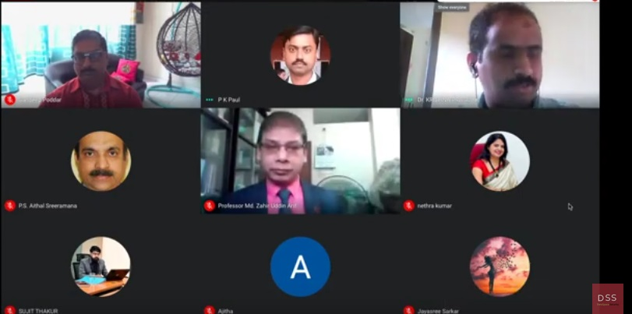
Dr. Krishna Prasad K, Convener, (ICONICYSEC-2021) expressed the to the media that, As a whole the Conference was remarkable with more than 200 attendees from different parts of India and World with diverse background. Importantly the Conference received about 100 papers and based on quality of the paper 43 paper presenters got opportunity to present their work in the areas of ICT, Cyber Security event Management, Social Science connected with ICT and Cyber Space. Dr. Manjula Sanjay Koti, Professor & HOD, Department of Computer Applications, Sir M. Visvesvaraya Institute of Technology, Bangalore was Chairperson for Track-1 and Dr. R. Senthamarai, Professor, CURIN in Chitkara University, Punjab was Chairperson for Track-2 and
Dr. P.K. Paul, Program Chair and Director, (ICONICYSEC-2021) expressed that all the presenter presented their work free of cost and even all the selected papers will be published in International Journals published by the Srinivas Publications (Srinivas University) and there will be also an Hardcopy based Research Paper Publication Opportunity in Research based Book of New Delhi Publishers, New Delhi, India. On the occasion of ICONICYSEC-2021 a Research based book also released which is Edited by Dr. P.K. Paul (India) and Dr. A. Kumar (Ethiopia) on ‘Information Systems and Technology: The Advances and published by New Delhi Publishers, New Delhi, India with full sponsorship. On this occasion Prof. P.S. Aithal expressed his wishes to Dr. Paul and ask the student to follow Dr. Paul as a role model in research and innovation, he further stated honest and hard worker academician Dr. Paul is the real example of interdisciplinary research.
It is important to note that, Dr. P.K. Paul acted as a Program Chair and Director. Dr P.K. Paul who is from Raiganj University, West Bengal but also connected with Srinivas University since 2017. He also grabbed the Position of Chief Advisor (Innovative Program & Research Planning)at Srinivas University since 2020.He is also Executive Secretary, ICCRD-CUICI Argentina the said Associate Institute of this Conference.
The Conference was organized with effective supervision of Dr. Krishna Prasad K, who is an Associate Professor, College of CSIS and Director, Research Council (CSIS); and a Post Doctoral Fellow of Srinivas University. The Conference graced with over 50 members including Chief Patron (Sri. CA. A. Raghavendra Rao, Chancellor), Patrons (Dr. A. Srinivas Rao, Smt. S. Mitra Rao, Dr. Anil Kumar), General Chair (Prof. P.S. Aithal), Chief Mentor (Prof. Bashiru Aremu), International Advisors, National and International TPC Members—globally.
Dr. Nethravathi P. S., Professor, College of Computer science and Information Science actively involved in the conference by chanting Prayer in Inaugural Session, Introducing the guest and coordinating one track of Paper Presentation Session.
The Conference become successful for the positive involvement of the Co-Convenors, and Prof. Nethravathi and Prof. Jayanthiladevi, Organizing Secretaries—Prof. Shridhara Acharya, Prof. Subhramanya Bhat. Jt. Organizing Secretaries as Prof. Vaikunta Pai and others.

Virtual Webinar on Tips for writing an effective research paper
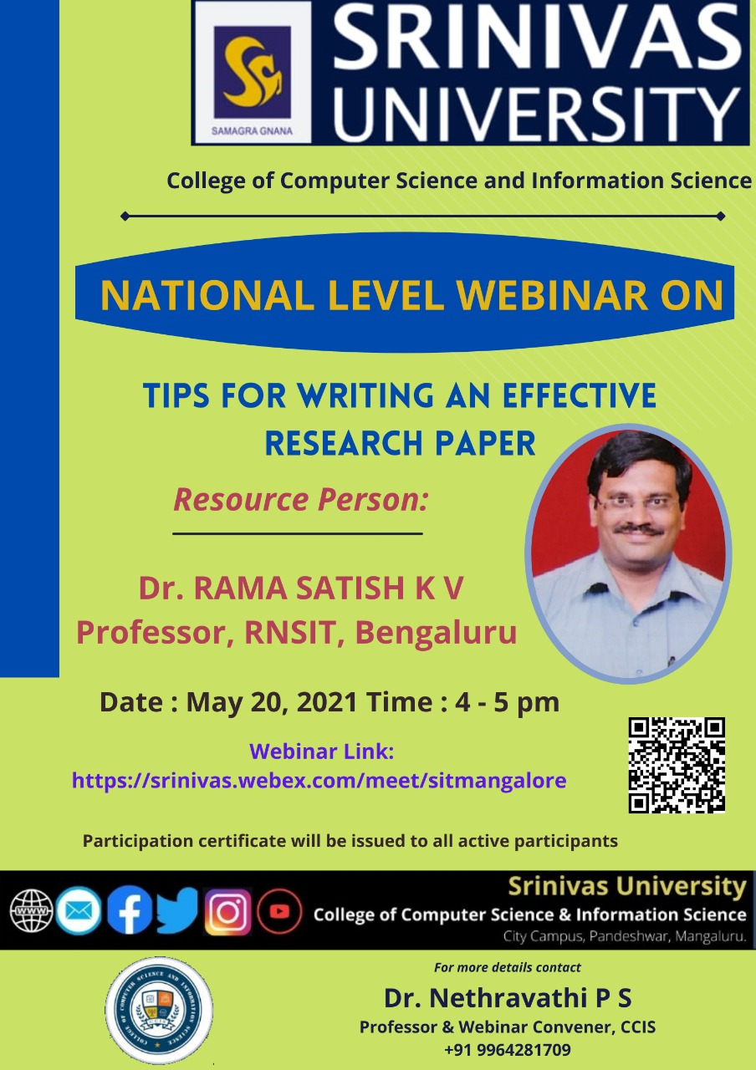
College of Computer Science and Information Science, Srinivas University
Conducted a National Level Webinar on the topic “Tips for writing an effective research paper” on 20th May, 2021. Dr.Rama Satish K.V, Professor RNSIT, Bangalore was the resource person. He delivered talk on how to understand he assignment, how to do research with efficiency. He explained how to create the perfect writing environment and to focus standard structure. He told participants the important tips in writing quality articles. More than125 participants from various places participated in this workshop. Dr.P.S.Aithal, Vice chancellor of the university and Dean of CCIS, Prof. Subhramanya Bhat were present. Dr.Nethravathi P.S, Professor of CCIS was the convener for this program and welcomed the speaker. Dr.Krishna Prasad K, Associate Professor, CCIS gave the vote of thanks.
Virtual Webinar Technology Development and Entrepreneurship
College of Computer Science and Information Science, Srinivas University organized a National Level Webinar on “Technology Development and Entrepreneurship” on 26th May 2021. Dr.Y.Shrihari Upadhyaya, CEO, Manipal Universal Technology Business Incubator, Manipal was the resource person. In his speech he explained how to become an entrepreneur. He demonstrated many live examples of successful entrepreneurs. He listed the support from the government and new initiatives for the start-ups. At the end he gave hint on funding available and how to manage with the funding of start-ups or incubators. Over 175 participants from various places participated in this workshop. Dr.P.S.Aithal, Vice chancellor of the university and Dean of CCIS, Prof. Subhramanya Bhat were present. Dr.Nethravathi P.S, Professor of CCIS was the convener for this program and welcomed the speaker. Dr.Krishna Prasad K, Associate Professor, CCIS gave the vote of thanks.

Virtual Webinar on Importance of Patents and Publications for Faculty and Students
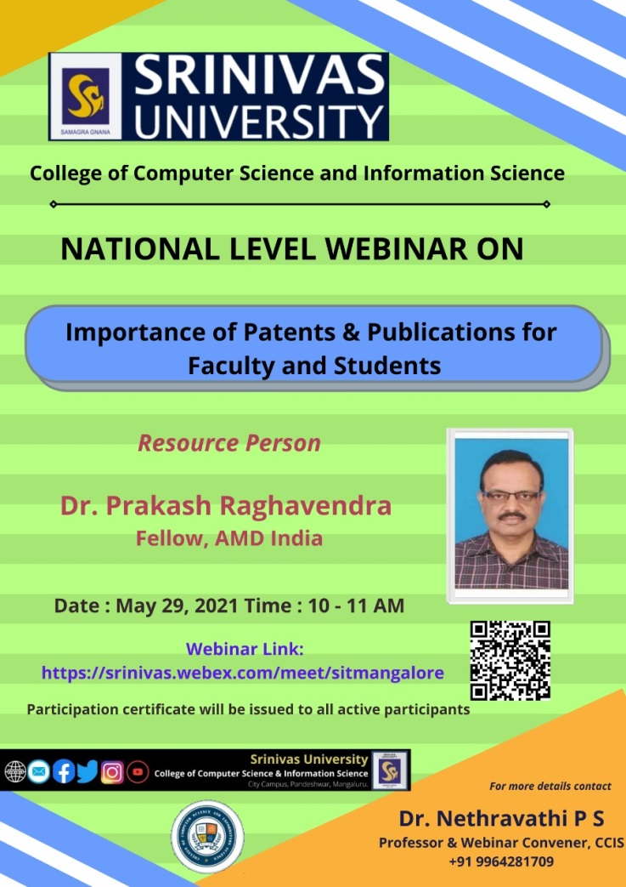
College of Computer Science and Information Science, Srinivas University organized a National Level Webinar on “Importance of Patents and Publications for Faculty and Students” on 29th May 2021 Dr. Prakash Raghavendra, Fellow, AMD India was the resource person. In his speech he explained Importance of Patent for teaching community and how this gives good value and points in APA Score. Over 150 participants from various places participated in this workshop. Dr.P.S.Aithal, Vice chancellor of the university and Dean of CCIS, Prof. Subhramanya Bhat were present. Dr.Nethravathi P.S, Professor of CCIS was the convener for this program and welcomed the speaker. Dr.Krishna Prasad K, Associate Professor, CCIS gave the vote of thanks.

Research and Innovation council, Srinivas university, Mukka,Mangalore
Webinar on Research Step 1,2,3 conducted on June 1st to June 5th -2021
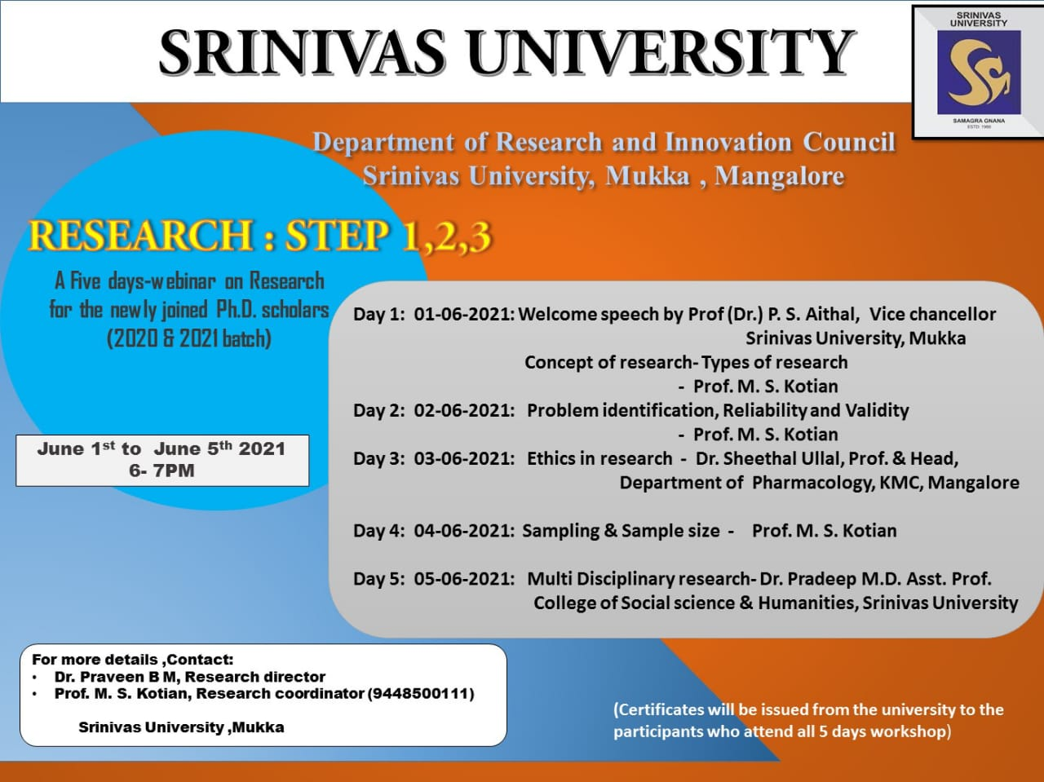
A Five days webinar on research methodology was conducted by research and innovation council, Srinivas university on 1st June till 5th June 2021. Dr. Krishna Prasad K, Associate Professor in computer science welcomed the Vice chancellor and the resource persons as well as all the delegates who were participating in the webinar. The programme was started with the welcome speech by Prof. (Dr.) P.S. Aithal, Vice chancellor of Srinivas University. He briefed about the importance of research as well as this webinar on research methodology. He insisted the scholars should be alert on the current happenings so that their research will be fruitful.
The first session was on Ist June and was taken by Prof. Shashidhar Kotian, Professor in research , Srinivas University, Mukka on Concept of research , types of research . He in his talk explained the importance of research, various types of research and the concept of research. On 2nd June the topic was Problem identification , reliability and validity and was taken by Prof. Shashidhar Kotian, where he discussed how to identify the problem and selecting the topic. Also briefly explained about the various types of methods in Reliability and Validity. On the third day ethics in research was discussed and the resource person was Dr. Sheethal Ullal, Professor and head of Pharmocology department ,Kasturba Medical college, Mangalore. She briefly given the importance of ethics particularly in Allied health science, Physiotherapy and Nursing . Also insisted the importance of ethics in social science. Fourth day session was taken by Prof. Shashidhar Kotian on Sampling methods and sample size where he explained the various random and non random sampling methods and discussed how to calculate the sample size for various study designs . The fifth day webinar was conducted by Dr. Pradeep M.D., Assistant professor ,College of social sciences and humanities, Srinivas University . He discussed the multi disciplinary research.
All the five days on an average of 200 scholars attended the webinar. Prof. Krishna Prasad thanked all the speakers and the delgates who attended the webinar. A five days webinar on research went on well with good speakers and well attended delegates.

Virtual Webinar on Role of AI in Transforming the World
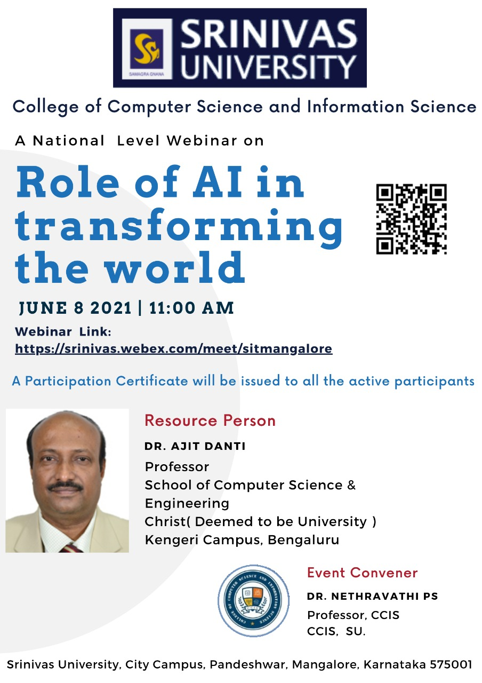
College of Computer Science and Information Science, Srinivas University organized a National Level Webinar on “Role of AI in Transforming the World” on 8th June 2021. Dr.Ajit Danti, Professor, School of Computer Science and Engineering, Christ, (Deemed to be University), Kengeri Campus, Bangalore was the resource person. In his speech he explained how Artificial Intelligence influences every walk for of our life today. He demonstrated many live examples of Artificial Intelligence to real life. Over 130 participants from various places participated in this workshop. Dr.P.S.Aithal, Vice chancellor of the university and Dean of CCIS, Prof. Subhramanya Bhat were present. Dr.Nethravathi P.S, Professor of CCIS was the convener for this program and welcomed the speaker. Dr.Krishna Prasad K, Associate Professor, CCIS gave the vote of thanks.

Virtual Webinar on Computers, Ethics and Social values
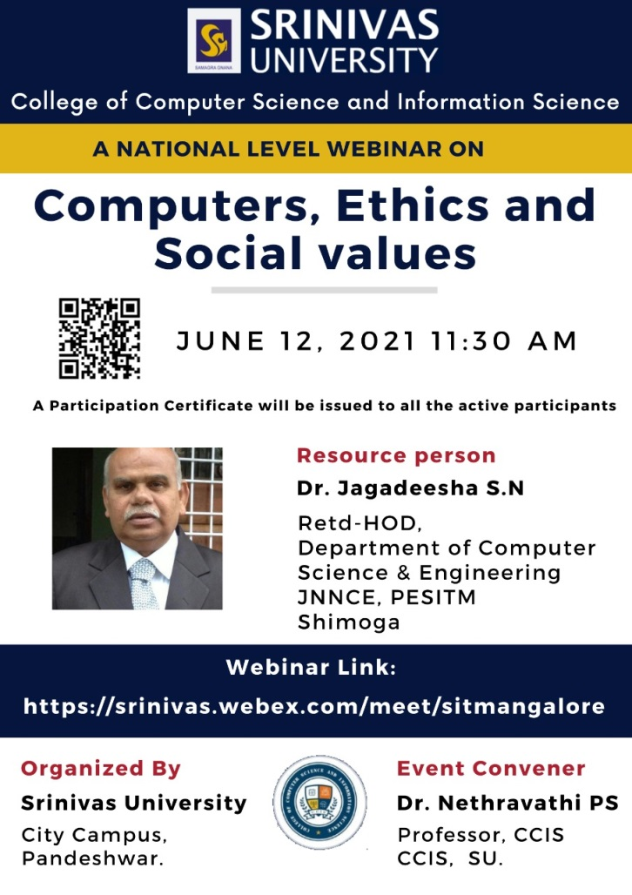
College of Computer Science and Information Science, Srinivas University organized a National Level Webinar on “Computers, Ethics and Social values” on 12th June 2021. Dr. Jagadeesha S.N Retd-HOD, Department of Computer Science & Engineering, JNNCE, PESITM, Shimoga, was the resource person. In his speech he explained how Computers are connected with various Walks of life. He demonstrated many live examples of Computer Ethics and Social Values. Over 140 participants from various places participated in this workshop. Dr.P.S.Aithal, Vice chancellor of the university and Dean of CCIS, Prof. Subhramanya Bhat were present. Dr.Nethravathi P.S, Professor of CCIS was the convener for this program and welcomed the speaker. Dr.Krishna Prasad K, Associate Professor, CCIS gave the vote of thanks.

International Conference on the topic “Emerging Trends in Computer Science & Technology”, on June 18th and 19th 2021
College of Computer Science and Information Science of Srinivas University organizing an Vitrtual International Conference on the topic “Emerging Trends in Computer Science & Technology”, on June 18th and 19th 2021 from morning 9 am to 5 pm. The virtual inauguration will be held between 8.30 am to 10 am. The international speakers Dr.Steven Fernandes, Postdoctoral Researcher, University of Central Florida, USA, Dr.AliReza Alaei, Faculty of Science and Engineering, Southern CrossUniversity, Australia, Dr. Shivakumar, Faculty of Computer Science & Information Technology, University of Malaya, Malaysia will be giving the message on the conference theme during the inauguration session. At 11.30 am Dr.AliReza Alaei will be taking the session on the topic Measuring Human Satisfaction based on Big data and Artifical Intelligence Approach : Application in Tourism. At 12.30 pm Dr. Shivakumar will be talking on Forged Text Detection and at 1.30 pm Dr.Prakash Kumar Udupi, will be taking the session on Lean IT and FOSS-Towards new way of using IT in Business. At 3 pm 65 research scholars are presenting their research work. The research presentation will be chaired by the eminent professors from the computer science and engineering departments of various prestigious institution namely Dr.Arun Kumar B.R, Dr.Nagesh H.R, Dr.Karuna Pandith, Dr.Manjula Sanjay Koti, Dr.Hansavath Bharadwaj and Dr.Shailashree will be the session chair for the management research presentation.
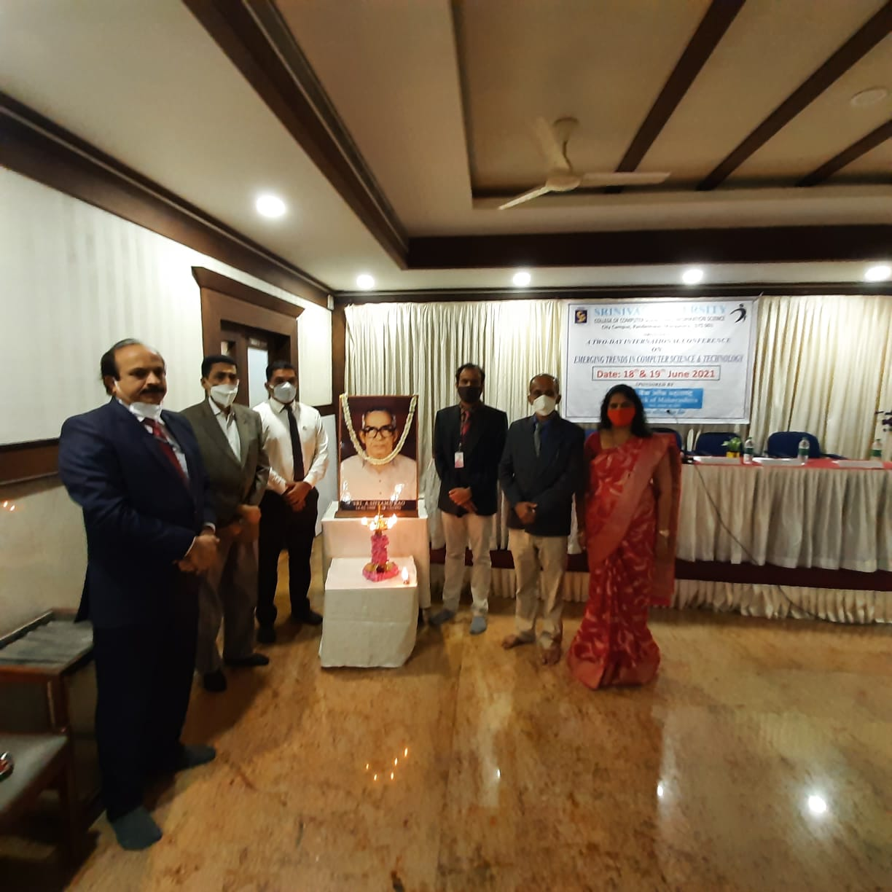
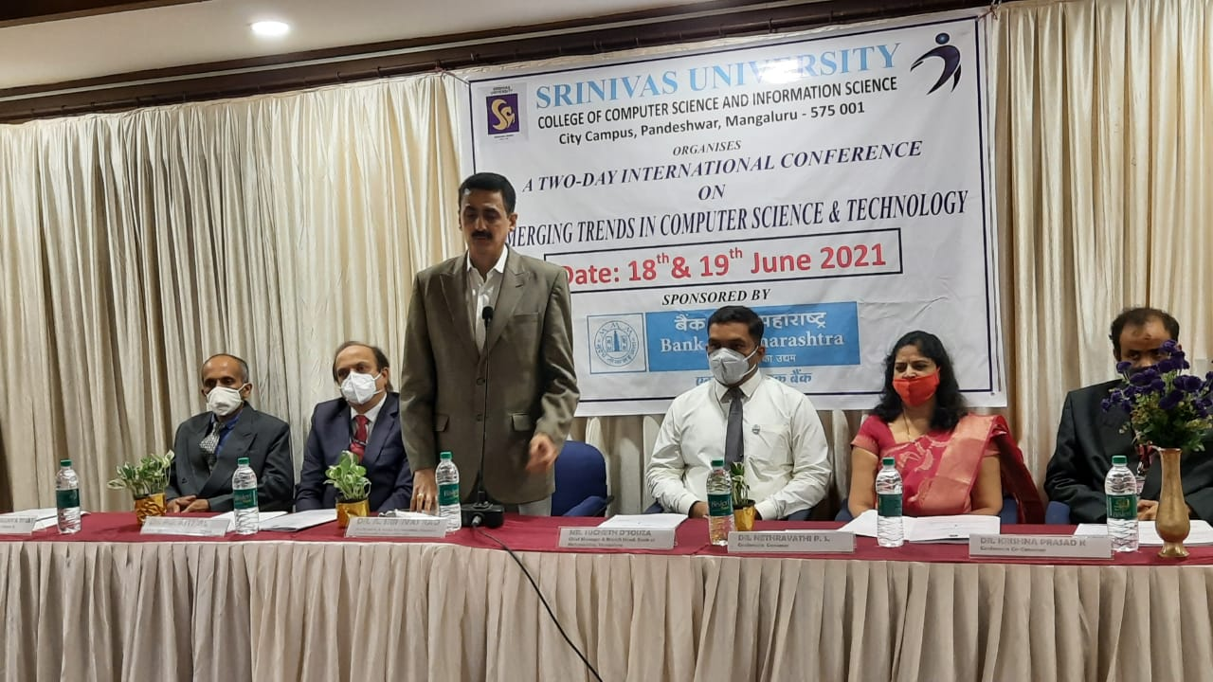
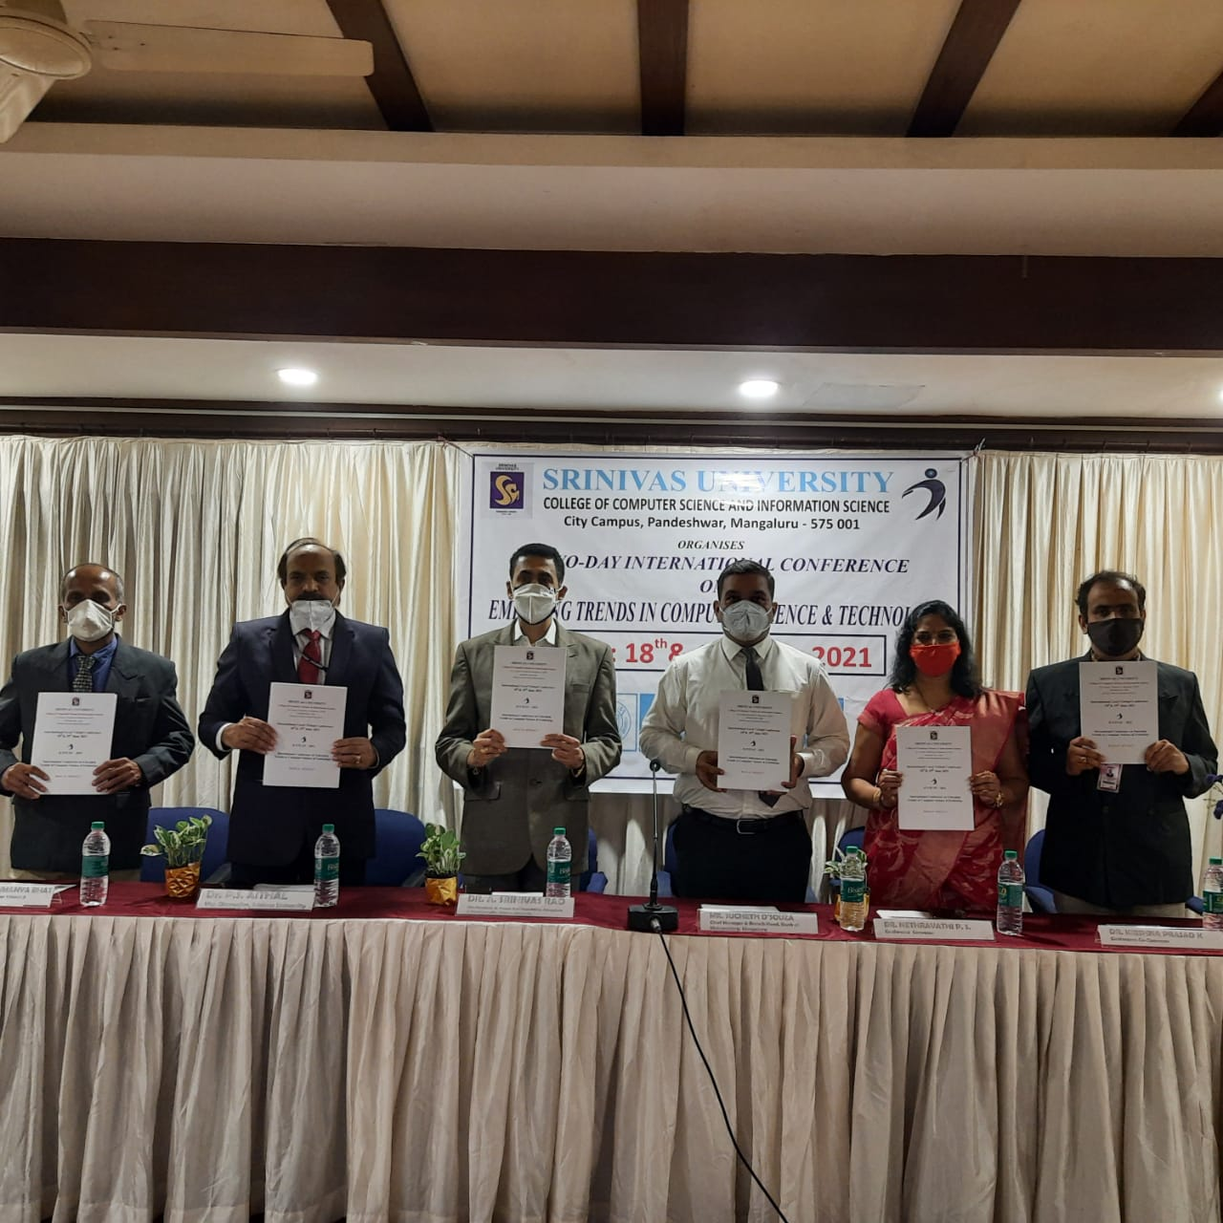

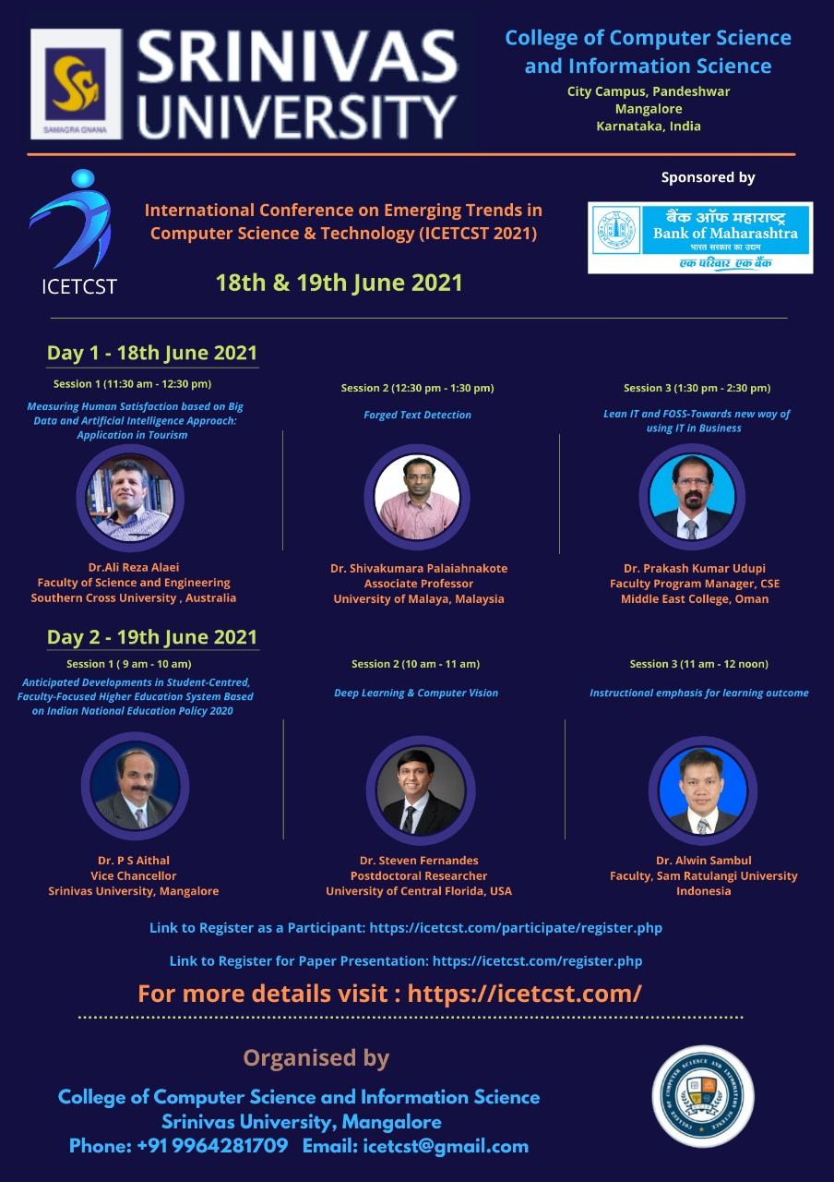
On 19th June 2021, at 9 am the keynote begins with Dr.P.S.Aithal, Vice chancellor of Srinivas University on the topic Anticipated developments in student-centred faculty-focused Higher Education System Based on Indian National Education Policy 2020. At 10 am Dr.Steven Fernandes, Postdoctoral Researcher, University of Central Florida, USA, on the topic “Deep Learning and Computer Vision” at 11 am Dr.Alwyn will be talking on Instructional emphasis for learning outcomes. Afternoon at 2 pm research topics will be presented till 4 pm. For more details on the conference visit https://icetcst.com/
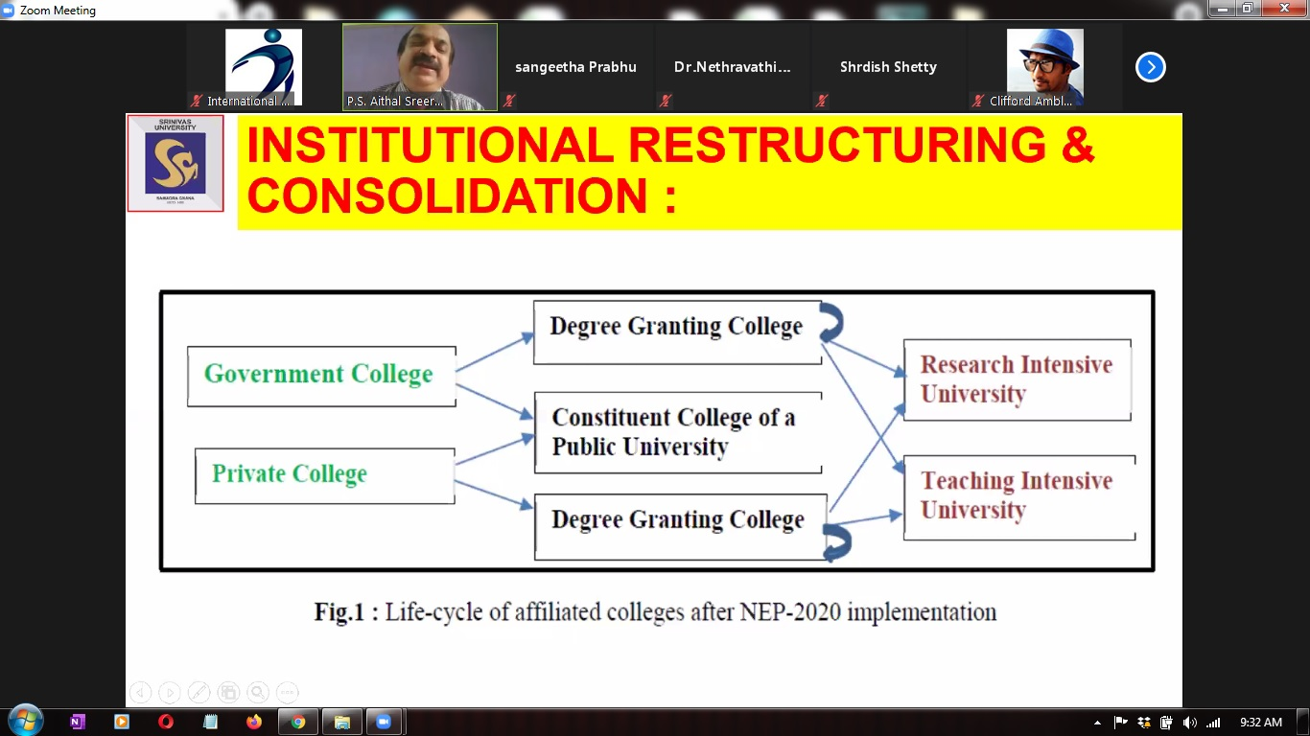
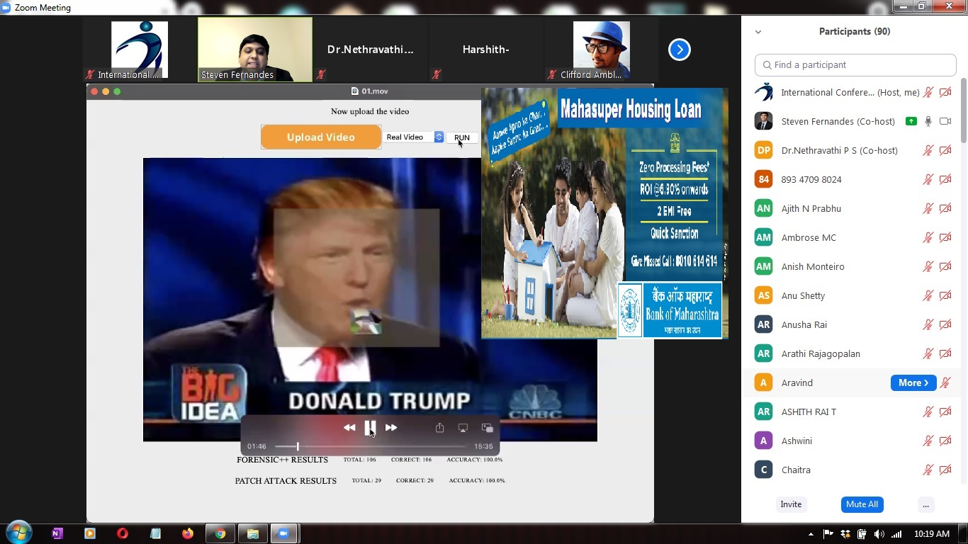

IEEE Srinivas University Student Branch
Technical Talk
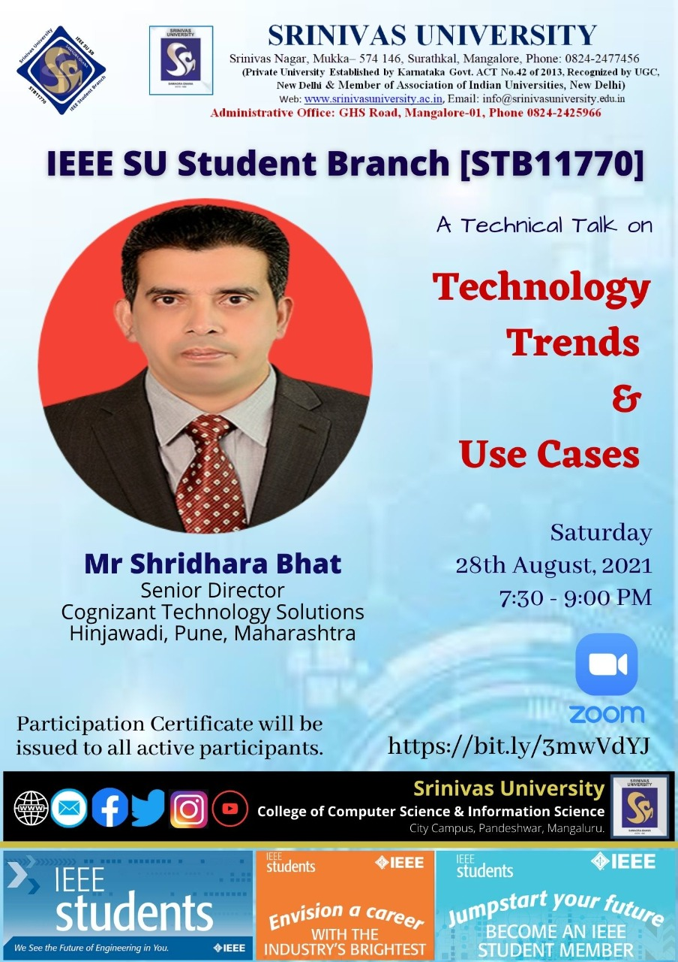
Date: 28-08-2021 Time: 7: 30 P.M. to 9:00 P.M. Platform: Google Meet
The Srinivas University IEEE Student Branch organized a Technical Talk on “Technology Trends and Use Cases” on the 28th of August 2021, Mr Shridhara Bhat, Senior Director, Cognizant Technology Solutions, Pune was the resource person. In his session, he explained the how emerging technologies have become part and parcel of human life, how they have brought transformed the human life.
“Digital transformation has become competitive requirement for every sector. Use of emerging technologies have integrated several heterogeneous sectors and made the life of human beings easy and comfortable. It is through the use of technology the world is still surviving during the situation of the outbreak of COVID-19 pandemic. Technological advancement has opened up plenty of opportunities for business and research. Only the thing is one must wisely use the right technology in the right place. Almost all sectors including farming, healthcare, banking, etc. are becoming smart by proper use of technology.” he said.
Dr. Krishna Prasad K, Counselor, IEEE SUSB guided the proceedings of the webinar. Mr Vinayachandra, Chair, IEEE SUSB welcomed everyone and introduced the resource person. Mrs Rajeshwari proposed a vote of thanks. The session was compered by Geetha Poornima.
The program was attended by approximately 100 participants, including members of the Srinivas University Student Branch and Research Scholars of Srinivas University.

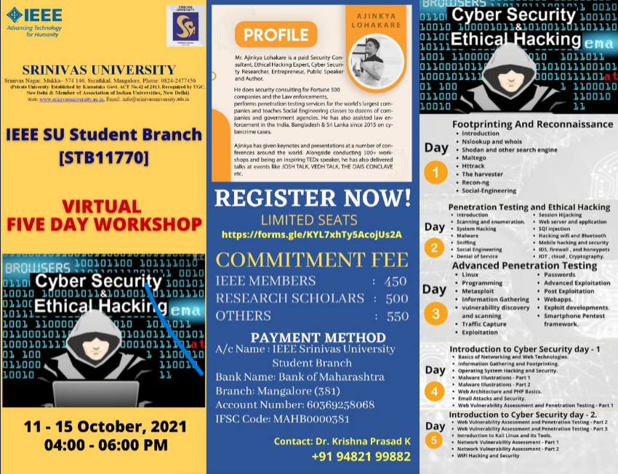
Five Days Workshop on Cyber Security and Ethical Hacking
The Srinivas University IEEE Student Branch organized a workshop on Cyber Security and Ethical Hacking Between 11th October 2021 and 15th October 2021. Mr Ajinkya Lohakare, Cyber Security Consultant and Ethical Hacker was the resource person. The entire workshop was divided into two parts. First three days different concepts related to ethical hacking were demonstrated. During the last two days the issues related to cyber security were demonstrated, During the workshop the fundamental concepts that distinguish ethical hacking from hacking, the different categories of hackers and how they operate, how to use the necessary tools for setting up your personal hacking environment, how to conduct reconnaissance/footprinting activities including passive/active reconnaissance simulations, how to conduct scanning activities with different scanning tools, in simulation mode, how to conduct enumeration activities with different enumeration tools, in simulation mode, Malware, sniffing, Session hijacking, SQI injection, Hacking of Bluetooth and Wi-Fi devices, vulnerability discovery, traffic capture and exploitation were explained.
Under cyber security advanced practical skillset in defeating all online threats - advanced hackers, trackers, malware and all Internet nastiness including mitigating government spying and mass surveillance, what are career opportunities in cyber security, how to become a cyber security specialist, operating system security, privacy, and patching - On Windows 7, Windows 8, Windows 10, MacOS and Linux, explore the threat landscape - Darknets, dark markets, zero day vulnerabilities, exploit kits, malware, phishing, etc. security through physical and virtual isolation and compartmentalization. Covering sandboxes, application isolation, virtual machines, malware illustrations, e-mail attacks and security, web vulnerability assessment ad penetration testing were explained. Most of the concepts were demonstrated using different tools.
Dr. Krishna Prasad K, Counselor, IEEE SUSB guided the proceedings of the webinar.
The workshop was attended by approximately 50 participants, including members of the Srinivas University Student Branch and Research Scholars of Srinivas University.

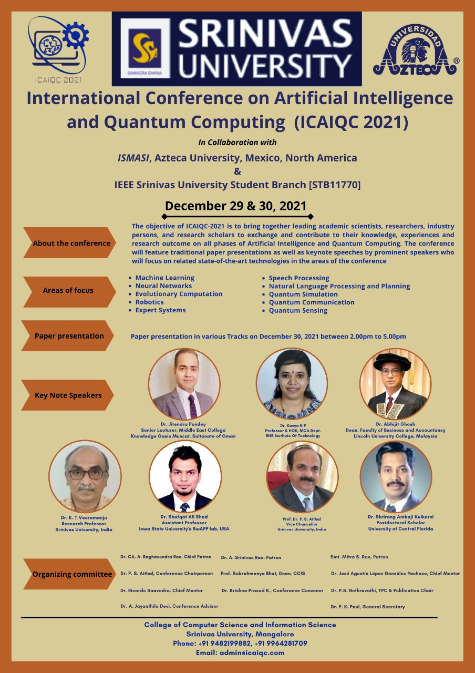
Virtual International Conference on the topic “Artificial Intelligence and Quantum computing”, on December 29th and 30th of 2021
The College of Computer Science and Information Science of Srinivas University organized a Virtual International Conference on the topic “Artificial Intelligence and Quantum Computing”, on December 29th and 30th 2021. The virtual inauguration held on 30th December 2021 at 10.00 AM. Dr. CA. A. Raghavendra Rao, Honourable Chancellor, Srinivas University presided in the Inaugural Session. Dr. Niranjan N. Chiplunkar, Principal, NMAMIT, Nitte, Karkala, Karnataka was the chief guest of the Inaugural Session. He pointed out the Importance of conducting a conference in Emerging fields of Artificial Intelligence and Quantum Computing to Research Students. Dr. Ricardo Saavedra Hidalgo, Director & Chair (International Program), Azteca University, Mexico, North America was Guest of Honour. The Conference Abstract book and Proceeding book of Previous International Conference on the theme “Emerging Technologies in Computer Science and Technology-ICETCST-2021 was virtually released jointly by Chief Guest, Dr. Niranjan N. Chiplunkar and Dr. P. S. Aithal Vice-Chancellor, Srinivas University. Dr. P. S. Aithal, Vice-Chancellor, Srinivas University, was president of the inaugural function. Dr. A. Srinivas Rao, Honourable Pro-Chancellor, Srinivas University, Mrs. Vijayalakshmi R. Rao, Director, Srinivas Group of Institutions, Mrs. Mithra S. Rao, Secretary, A. Shama Rao Foundation, were blessed the Inaugural function with their presence.
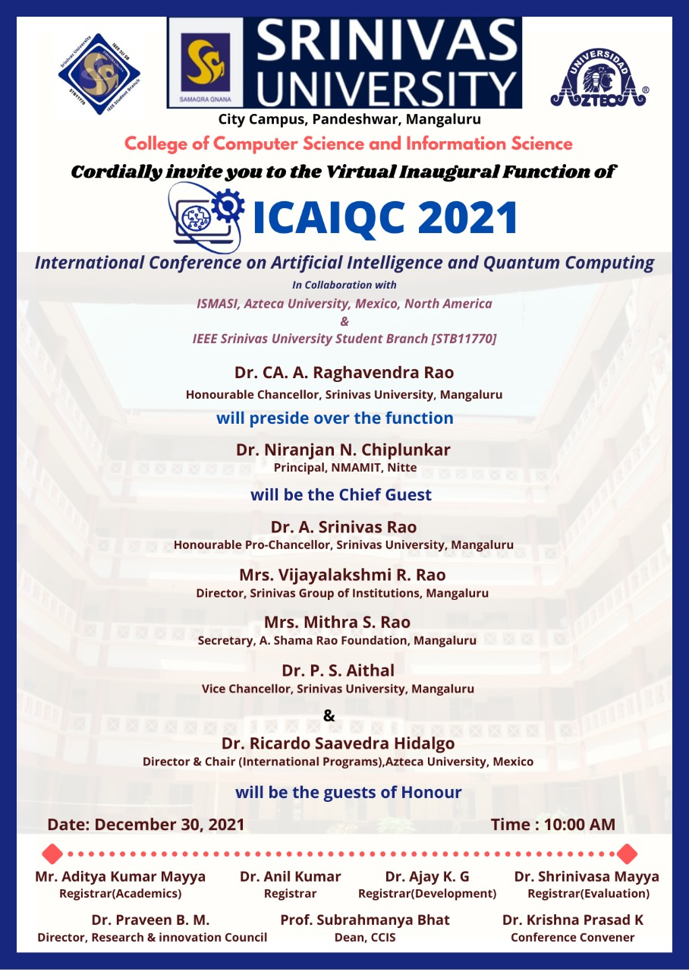
Dr. Nethravathi P. S., TPC & Publication Chair of the conference & Professor, College of Computer Science and Information Science, Srinivas University Welcomed the guest. Dr. Krishna Prasad K, Convenor of the conference and Associate Professor, College of Computer Science and Information Science, Srinivas University explained about the conference. Prof. Subrahmanya Bhat, Dean, College of Computer Science and Information Science, Srinivas University gave a Vote of thanks. Mrs. Divya Kumari Naveen, Faculty, College of Computer Science and Information Science, Srinivas University did Master of Ceremony.
The international speakers, Dr. Shrirang Ambaji Kulkarni, Post-Doctoral Scholar, University of Central Floride, USA, Dr. Jitendra Pandey, Senior Lecturer, Middle East College, Sultanate of Oman, Dr. Abhijit Ghosh, Dean Faculty of Business and Accountancy, Lincoln University College, Malaysia, and Expert National speakers, Dr. Kavya N P, Professor & HOD, MCA Department, RNSIT, Bangalore, Dr. P. S. Aithal, Vice-Chancellor, Srinivas University, Dr. K. T. Veeramanju, Research Professor, Srinivas University delivered the keynote address on different sessions on 29th and 30th December 2021. Around 80 papers related to the conference theme were presented by scholars from different parts of the country and abroad which includes faculty members and Research Scholars of Srinivas University also. The research papers are presented in multiple tracks. The session was chaired by the eminent professors from the computer science and engineering departments of Srinivas University. Dr. Srinivas Rao Kunte, Dr. Jagadeesha S N, Dr. A M Sudhakara, Dr. K. T. Veeramanju, Research Professors of Srinivas University chaired the Presentation Session.
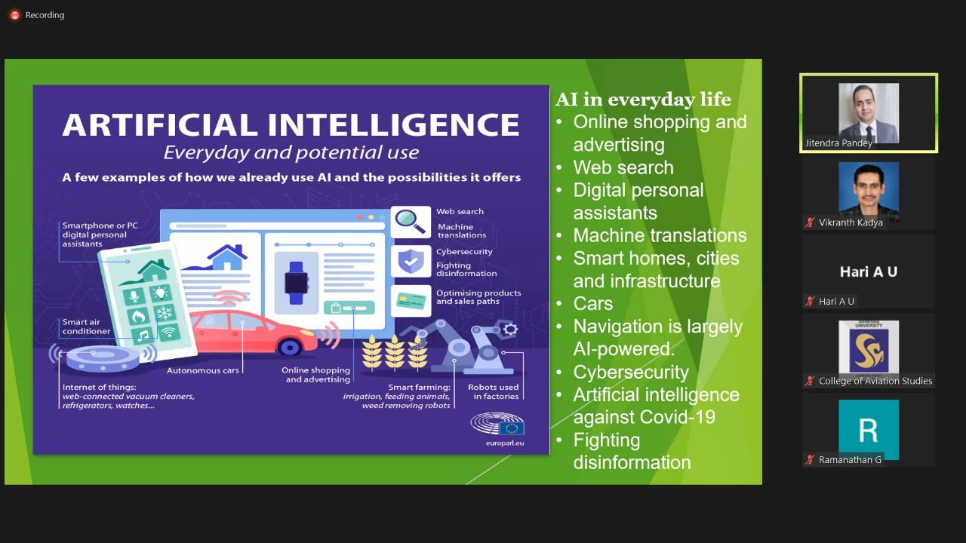
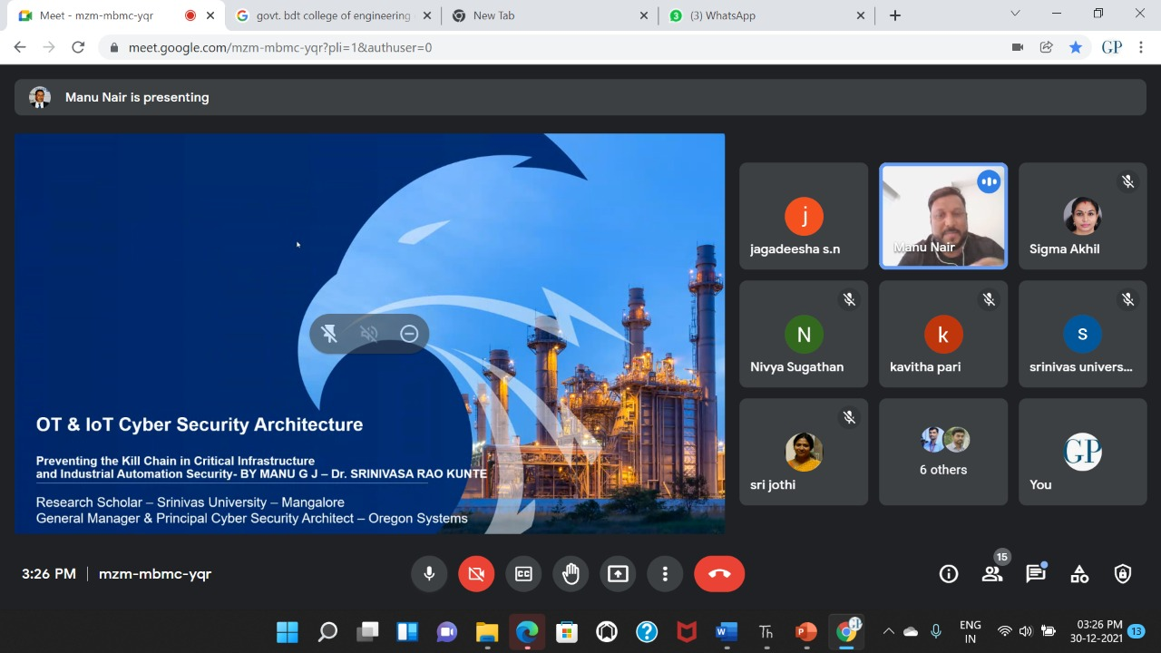

A Seminar on Introduction to Virtulization by Mr. Ragavendra Kumar, Manager-Cloud Management Support, Vmware Inc.

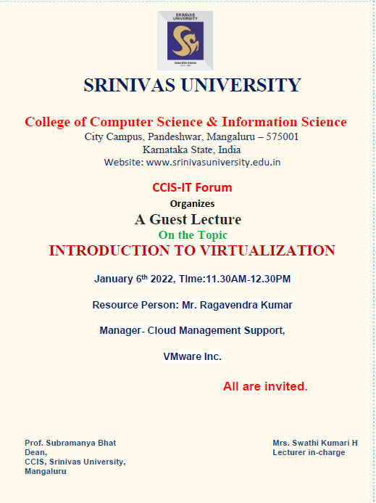
Institute of Computer Science and Information Science of Srinivas University Organized a Seminar on Introduction to Virtulization by Mr. Ragavendra Kumar, Manager-Cloud Management Support, Vmware Inc on 06th January 2022. Dr. P. S. Aithal, Vice chancellor was present for the programme. Dr. P.S. Aithal, Vice chancellor was present for the programme. Dr. Nethravathi P.S, Professor, ICIS welcomed the guest speaker. Prof. Subramanya Bhat, Dean of ICIS gave the vote of thanks.
The speaker explained about importance of Virtualization to students. About 90 students attended the technical talk.

A Technical Talk on Techniques of self-defense for woman by Karthik S Kateel, CEO, Swaraksha for Women Trust, Mangalore.

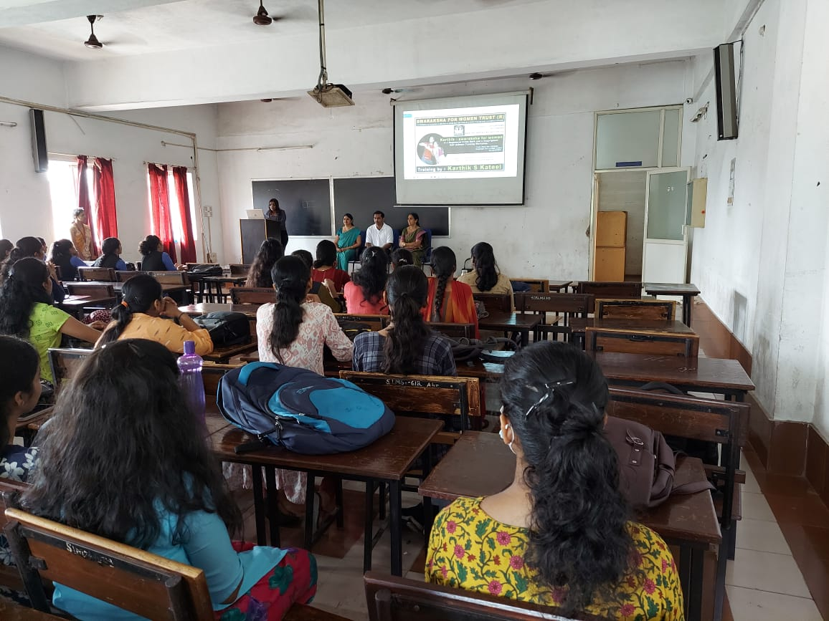

Institute of Computer Science and Information Science of Srinivas University Organized a Technical Talk on Techniques of self-defense for woman by Karthik S Kateel, CEO, Swaraksha for Women Trust, Mangalore on 06th April 2022. Dr. P.S. Aithal, Vice chancellor was present for the programme. Dr. P.S. Aithal, Vice chancellor was present for the programme. Dr. Nethravathi P.S, Professor, ICIS welcomed the guest speaker. Prof. Subramanya Bhat, Dean of ICIS gave the vote of thanks. Mr. Karthik demonstrated various methods and techniques of self-protection for women. About 80 students attended the technical talk.

A workshop on Unicort Day-2022 by Mr.Prashanth Shenoy, CEO of Mangalore Infotech on emerging technologies for MCA and BE students

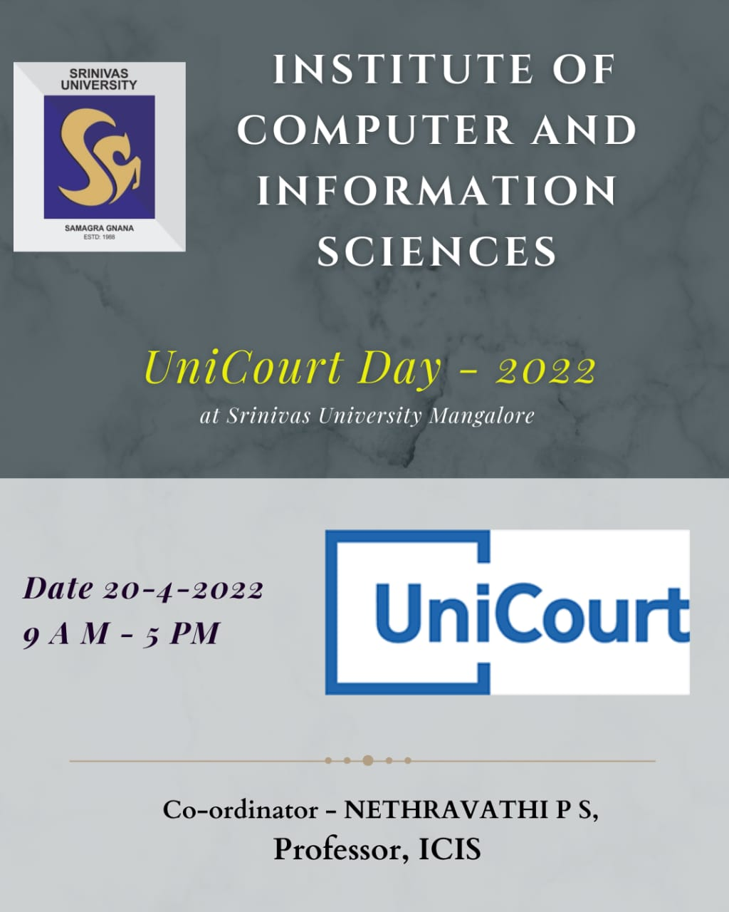

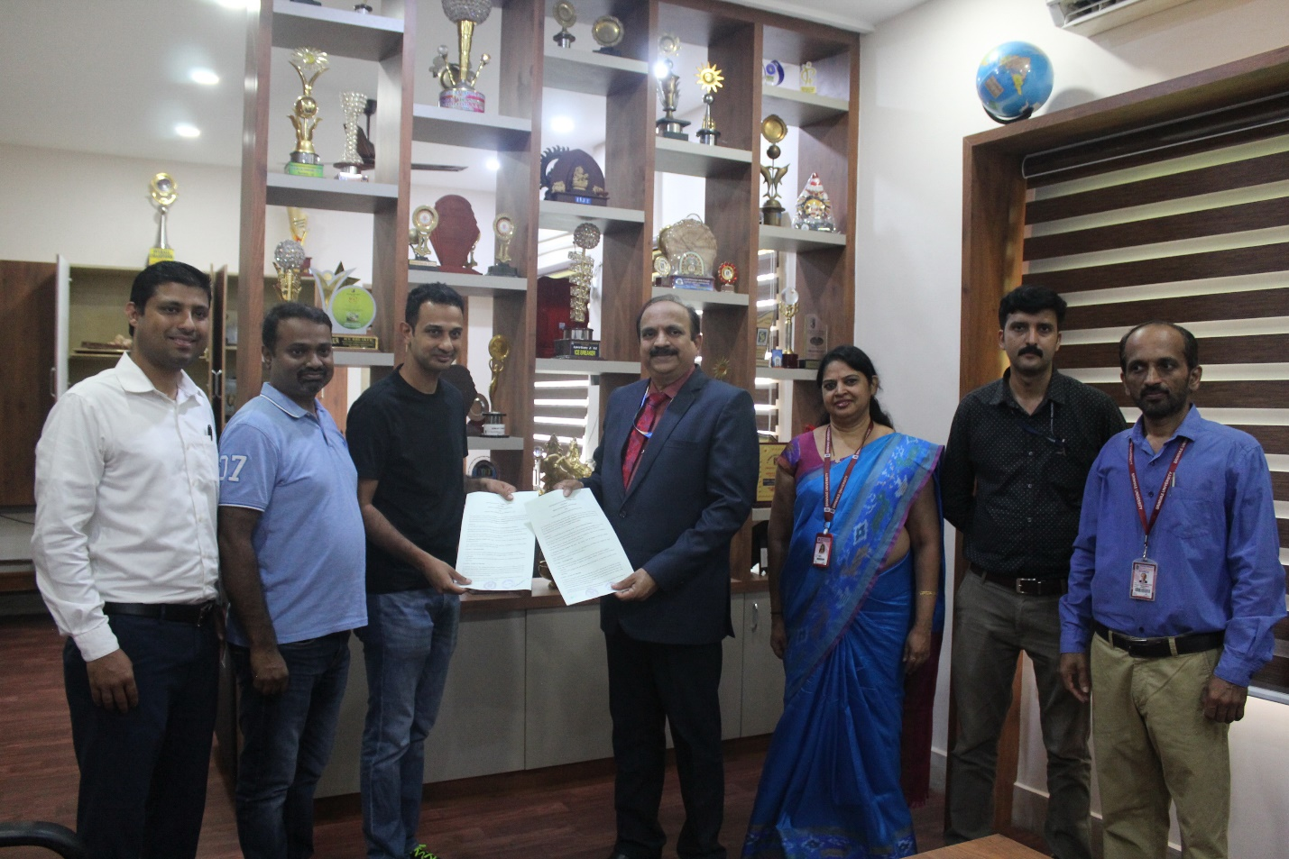
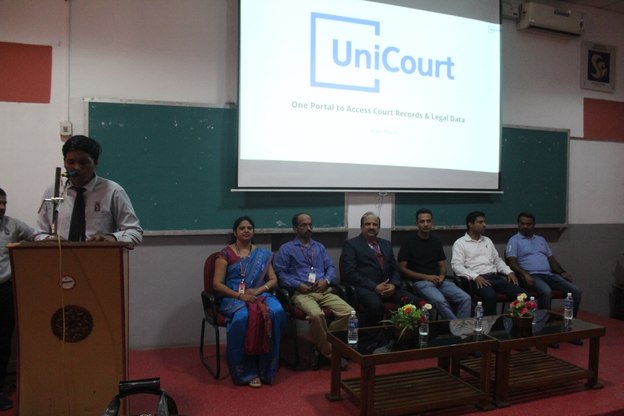

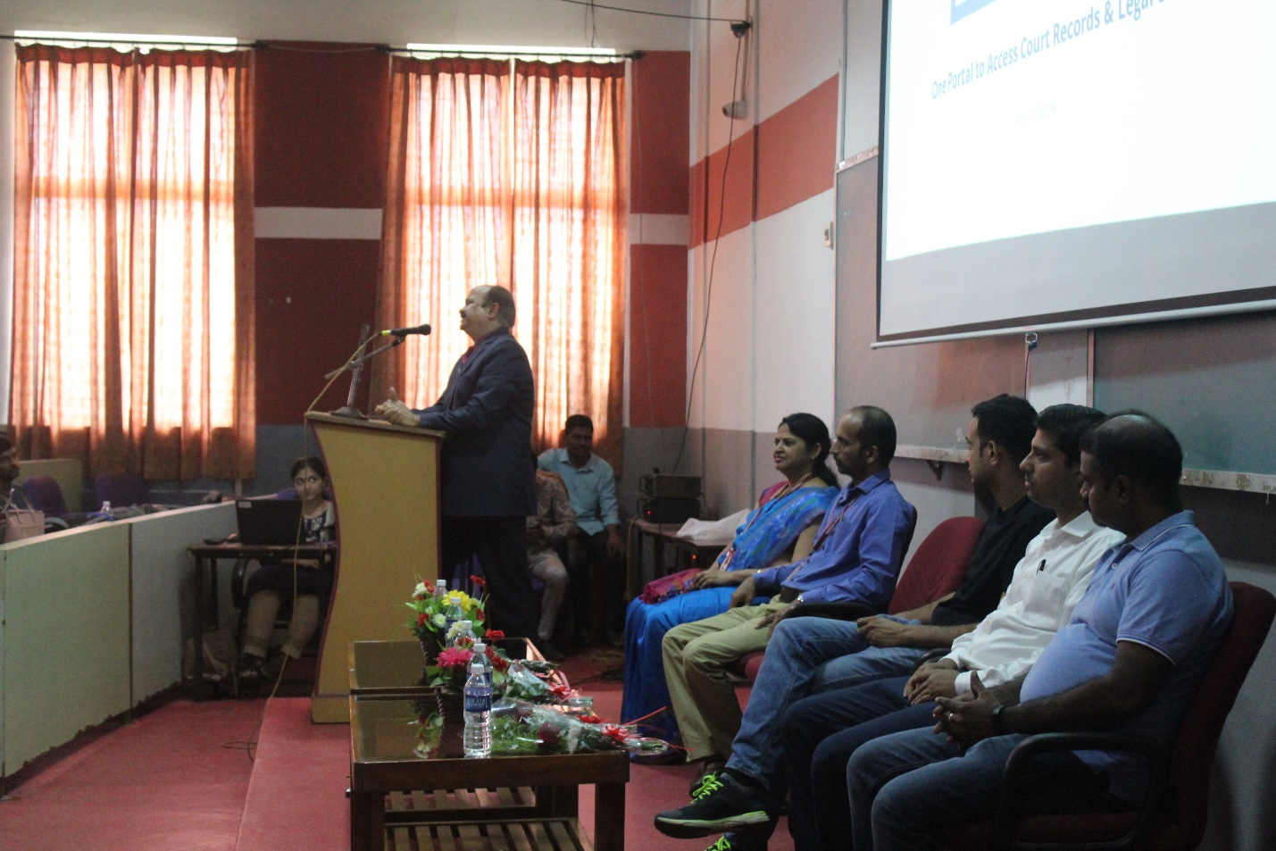

Institute of Computer Science and Information Science of Srinivas University Organized a workshop on Unicort Day-2022 by Mr.Prashanth Shenoy, CEO of Mangalore Infotech and his team on emerging technologies for MCA and BE students on 20th April 2022. Dr. P.S. Aithal, Vice chancellor was present for the programme. Dr. Nethravathi P.S, Professor, ICIS welcomed the guest speaker. Prof. Subramanya Bhat, Dean of ICIS gave the vote of thanks. About 150 students attended the workshop.

A Technical Talk on Socialpreneur - use technology to solve problems in a sustainable way by Mr.Raghunandan, Project Lead, Infosys, Mangalore

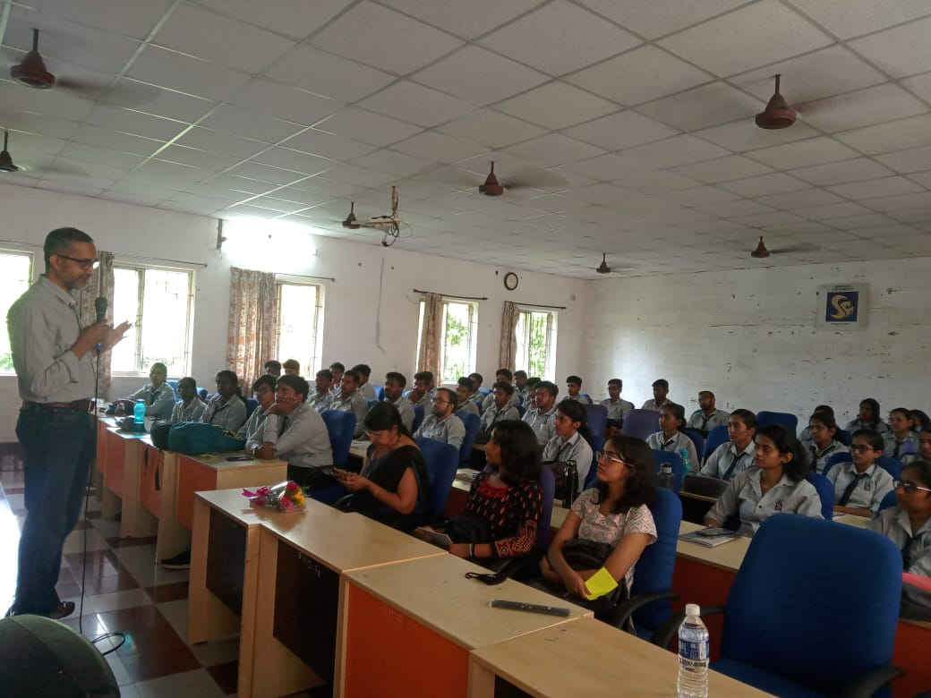

Institute of Computer Science and Information Science of Srinivas University Organized a Technical Talk on Socialpreneur - use technology to solve problems in a sustainable way by Mr. Raghunandan, Project Lead, Infosys, Mangalore on 28th of April 2022. Dr. P.S. Aithal, Vice chancellor was present for the programme. Dr. Nethravathi P.S, Professor, ICIS welcomed the guest speaker. Prof. Subramanya Bhat, Dean of ICIS gave the vote of thanks. About 60 students attended the Technical Talk.

A Technical Talk on Introduction to Forensics and Incident Response" by Professor Abdul Shareef, Jain University Bangalore
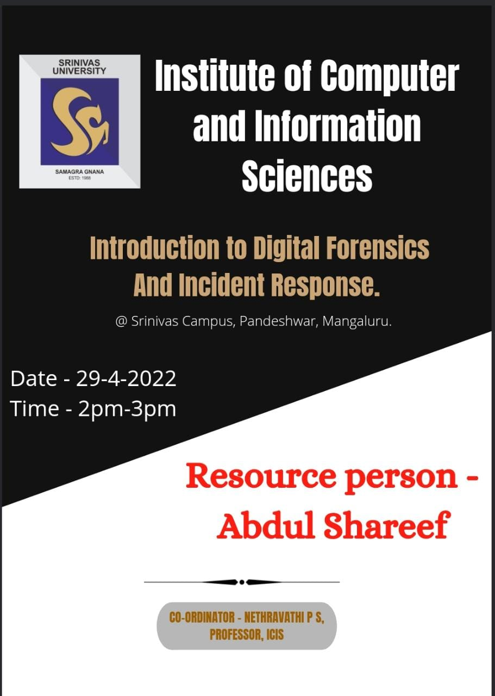

Institute of Computer Science and Information Science of Srinivas University Organized a Technical Talk on Introduction to Forensics and Incident Response" by Professor Abdul Shareef, Jain University Bangalore on 29th April 2022. Dr. P.S. Aithal, Vice chancellor was present for the programme. Dr. Nethravathi P.S, Professor, ICIS welcomed the guest speaker. Prof. Subramanya Bhat, Dean of ICIS gave the vote of thanks. About 65 students attended the Technical Talk. The Resource Person talked on importance of Digital Forensic and various methods used crime seen.

A Webinar on Illuminating Cyber crime & Digital Forensics by Mr. Deepak Kumar (D3), Senior Digital Forensics& Cyber Intelligence, India
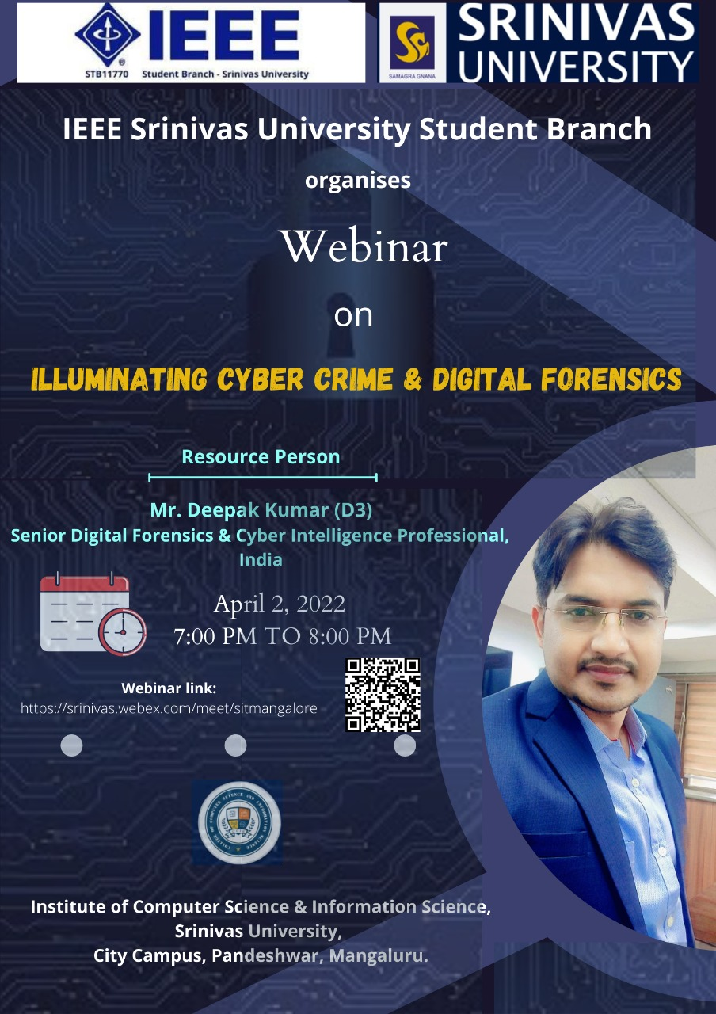

IEEE Srinivas University Student Branch [STB11770] organized a Webinar on Illuminating Cybercrime & Digital Forensics on 2nd April 2022 at 7 PM. Mr. Deepak Kumar (D3), Senior Digital Forensics& Cyber Intelligence, was the Resource Person. Mr. Deepak has been working on several consulting and investigating engagements with organisations such as Academia, Corporates, International Law Enforcement Organisations, and Government Sectors & PSUs. He is a highly interactive trainer & consultant, whose work is mainly based on research and applied knowledge from extensive experiences in digital forensics and cyber-security. He is also a subject matter expert in the domain such as Digital Forensics, Cyber Security, Cyber Crime & Terrorism, Threat Intelligence, (Open Source, and Dark Web & Social Media Intelligence).
Dr. P.S. Aithal, Vice chancellor and Prof. Subramanya Bhat, Dean of ICIS were present for the programme. Dr. Krishna Prasad K, Associate Professor of ICIS and Brach Counsellor, IEEE Srinivas University student branch welcomed the guest speaker. Mrs. Suchetha, Chair, IEEE Srinivas University student branch gave the vote of thanks. Around 50 Research Scholars and IEEE members attended the webinar.

A Webinar on Intellectual Property Rights (IPR)-Patents & Design Process by Mrs. Pooja Vishal Maulikar, Examiner of Patents and Designs, Patent Office, Ministry of Commerce & Industry

ICIS and IEEE Srinivas University Student Branch in association with Rajiv Gandhi National Institute of Intellectual Property Management (RGNIIPM), Govt. of India organized an Online Workshop on “Intellectual Property Rights (IPR) - Patent & Designs process” on 4th May 2022 at 12 noon. This workshop is being conducted under National Intellectual Property Awareness Mission (NIPAM). Dr. P.S. Aithal, Vice chancellor and Prof. Subramanya Bhat, Dean of ICIS were present for the programme. . Dr. Krishna Prasad K, Associate Professor of ICIS and Brach Counsellor, IEEE Srinivas University student branch welcomed the guest speaker. Mrs. Suchetha, Chair, IEEE Srinivas University student branch gave the vote of thanks. Around 50 Research Scholars and IEEE members attended the webinar.

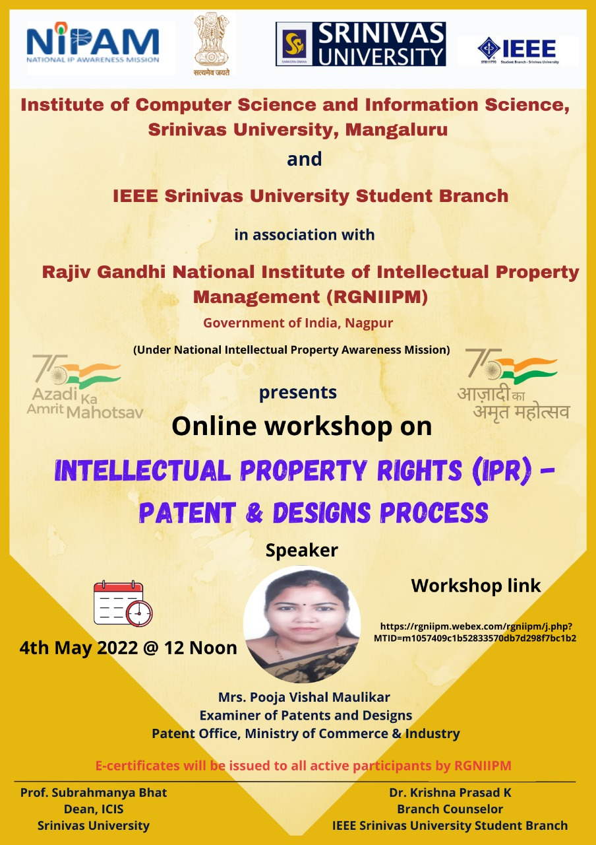
A technical Exhibition by BCA and MCA students, inaugurated by Sri.Vipin Kumar, Project Lead, Infosys, Mangalore

Institute of Computer Science and Information Science of Srinivas University Organized a technical Exhibition, inaugurated by Sri.Vipin Kumar, Project Lead, Infosys, Mangalore on 09th May 2022. Over 300 MCA and BCA students participated and witnessed this. Around 15 projects are exhibited by students. Dr. Nethravathi P.S, Professor, ICIS welcomed the guest speaker. Prof. Subramanya Bhat, Dean of ICIS gave the vote of thanks. The inaugurator explained the demand of IT field and importance various IT related technical Exhibition.
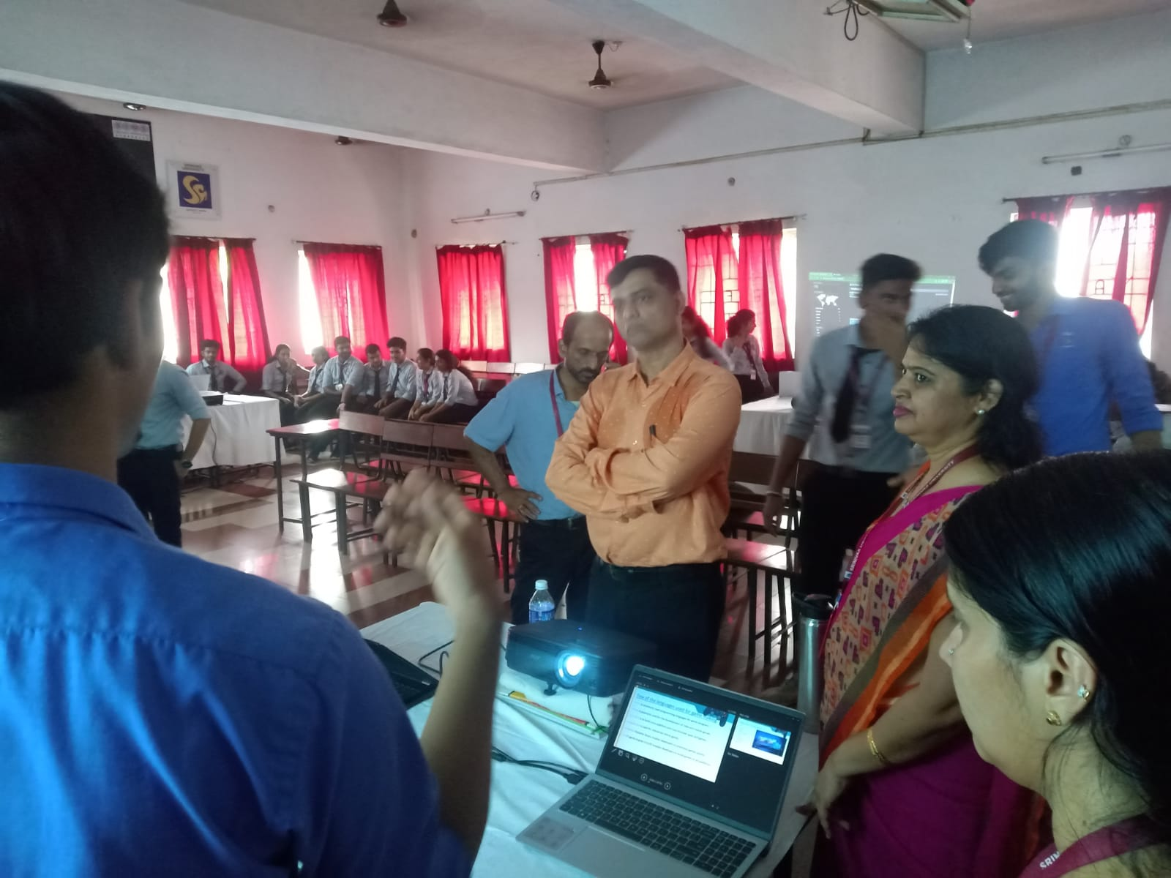

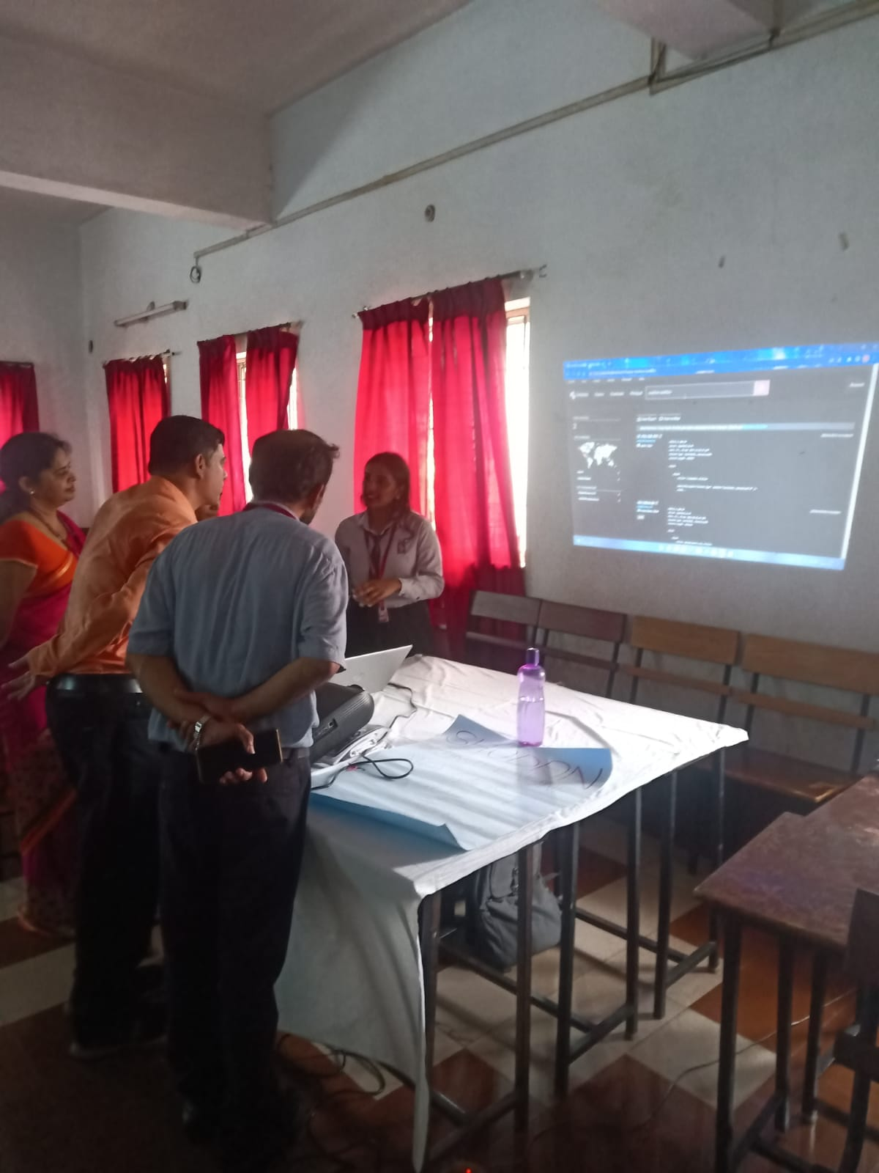

A Technical Talk on Future Trends in Machine Learning by Dr. Anoop B K, HOD, Department of AI, SIT, Valachil, Mangalore

Institute of Computer Science and Information Science of Srinivas University Organized a technical Talk on Future Trends in Machine Learning by Dr. Anoop B K, HOD, Department of AI, SIT, Valachil, Mangalore on 20th May 2022. . Dr. P.S. Aithal, Vice chancellor was present for the programme. Dr. Nethravathi P.S, Professor, ICIS welcomed the guest speaker. Prof. Subramanya Bhat, Dean of ICIS gave the vote of thanks. About 60 students attended the Technical Talk.

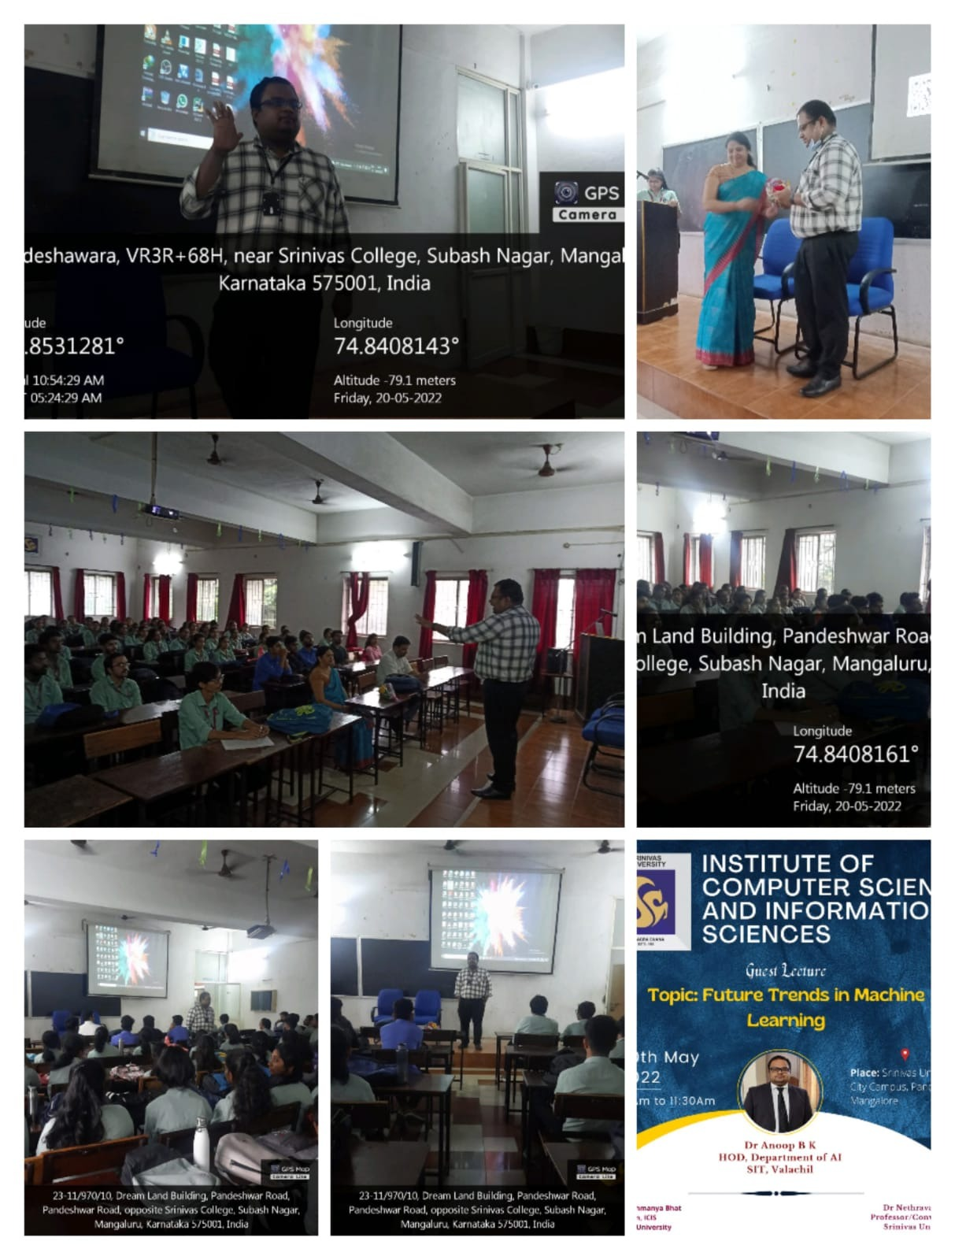

A Webinar on KAPILA Scheme and Patent Commercialization by Dr. Ganesh, Dean (Research), Velammal Engineering College, Chennai and Founder and Director of IP EVER LLP, Chennai
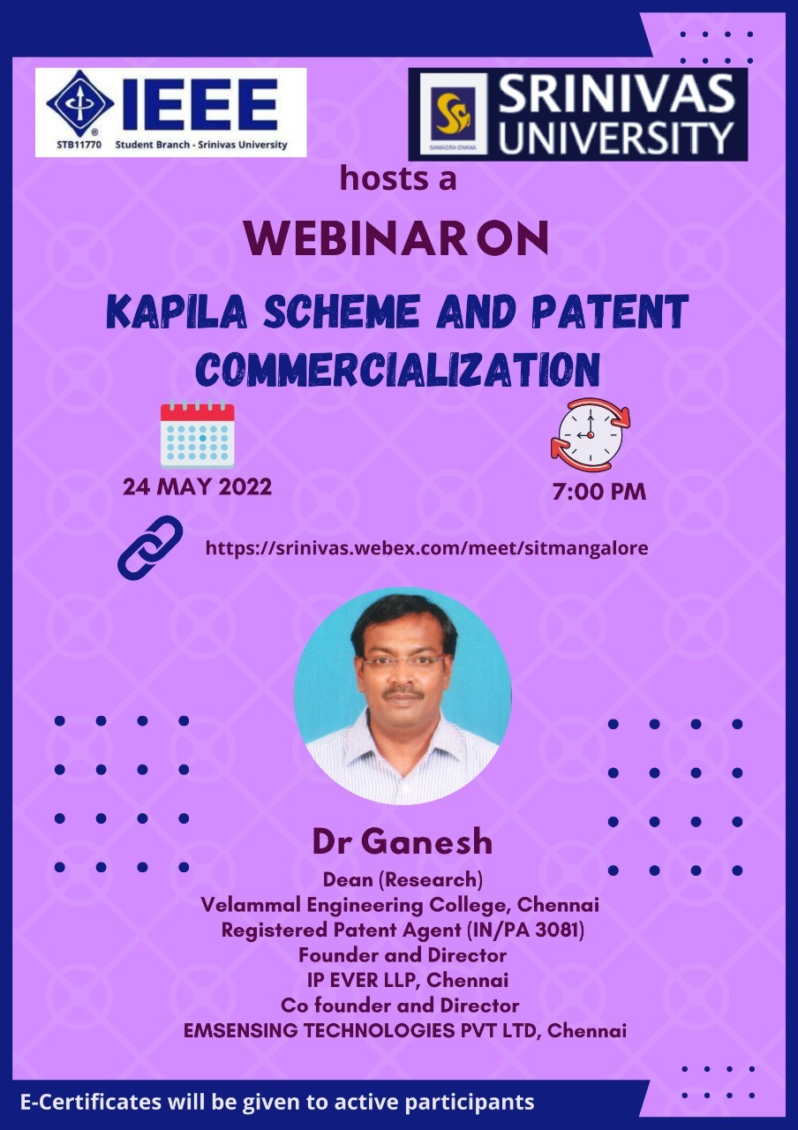
IEEE Srinivas University Student Branch [STB11770] in association with Institute of Computer Science and Information Science of Srinivas University Organized a Webinar on KAPILA Scheme and Patent Commercialization by Dr. Ganesh, Dean (Research), Velammal Engineering College, Chennai and Founder and Director of IP EVER LLP, Chennai on 24th May 2022 at 7.00 PM. Dr. Ganesh, Dean (Research), Velammal Engineering College, Chennai and Registered Patent Agent (IN/PA 3081), Founder and Director, IP EVER LLP, Chennai, CO founder and Director, EMSENSING Technologies Pvt Ltd, Chennai was resource Person. Dr. P.S. Aithal, Vice chancellor and Prof. Subramanya Bhat, Dean of ICIS were present for the programme. Dr. Krishna Prasad K, Associate Professor of ICIS and Brach Counsellor, IEEE Srinivas University student branch welcomed the guest speaker. Mrs. Suchetha, Chair, IEEE Srinivas University student branch gave the vote of thanks. Around 150 Students, Research Scholars and IEEE members attended the webinar.

A Technical Talk on Malaria Awareness by Dr. Bharathi Prakash, HOD, Dept. of Microbiology, University Constituent College, Mangalore University

Institute of Computer Science and Information Science of Srinivas University Organized a technical Talk on Malaria Awareness by Dr. Bharathi Prakash, HOD, Dept. of Microbiology, University Constituent College, Mangalore University on 28th May 2022. Dr. P.S. Aithal, Vice chancellor was present for the programme. Dr. Nethravathi P.S, Professor, ICIS welcomed the guest speaker. Prof. Subramanya Bhat, Dean of ICIS gave the vote of thanks. About 60 students attended the Technical Talk.

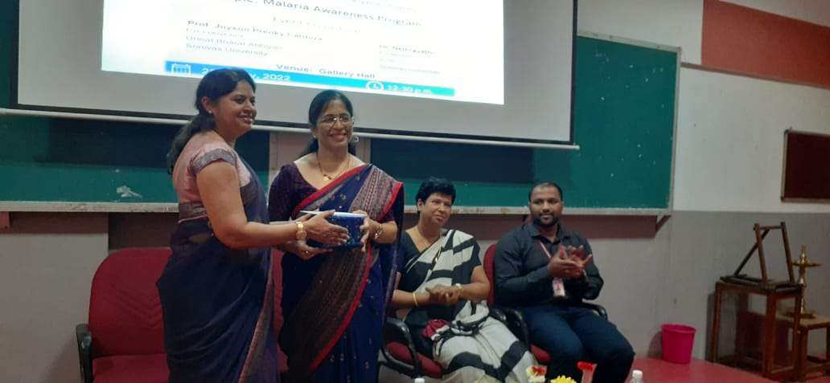

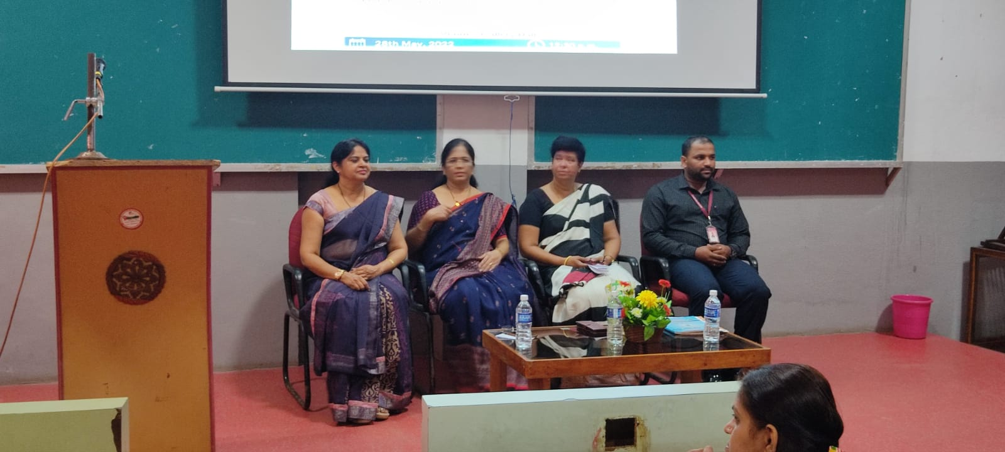

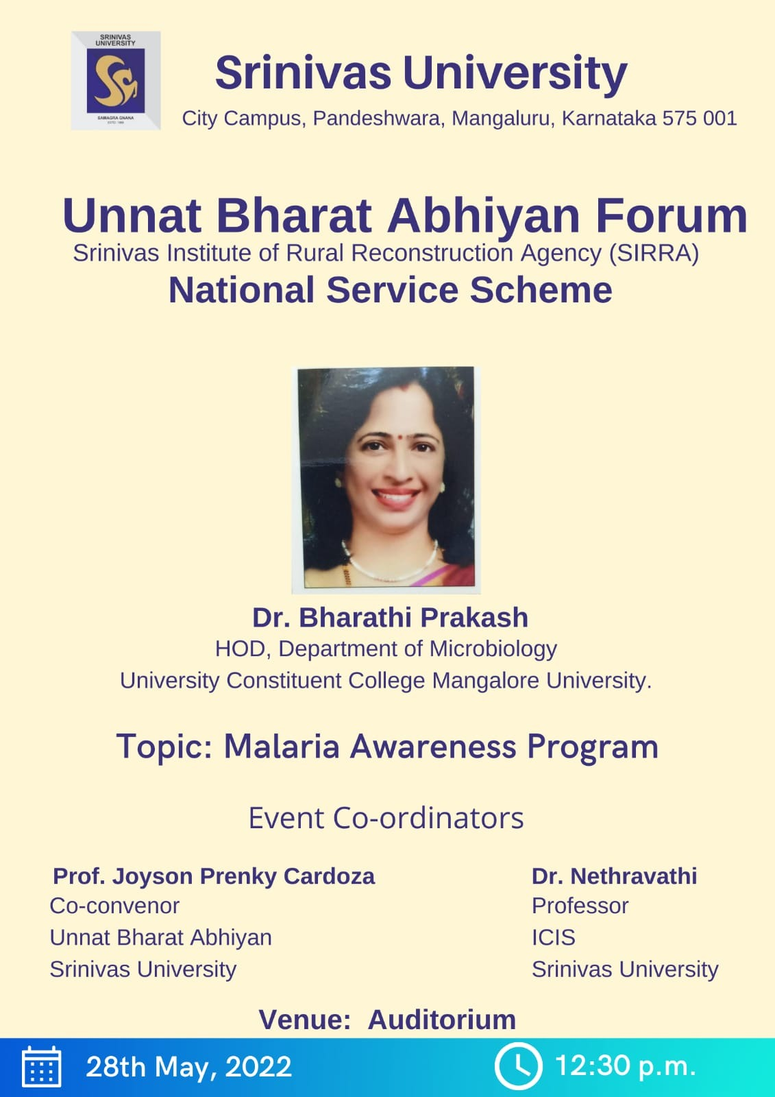

A Technical Talk on Entrepreneurship and Faculty Student Model for Institution Development by Prof. Shrihari Updyaya, CEO, Manipal Universal Technology Business Incubator
Institute of Computer Science and Information Sciences of Srinivas University conducted Faculty Empowerment program on the topic “Entrepreneurship through Incubation Centre with Faculty -Student-Alumni Model”on 31st May, 2022.
Prof. Shri Hari Upadhyaya CEO- Manipal Universe Technology Business Incubation Centre was the resource person. Dr. P S Aithal vice chancellor & Dr. Satya Sai Kumar Pro vice chancellor were also present. Prof. Subramanya Bhat Dean of ICIS deliver the vote of thanks. Dr.Nethravathi P.S, Professor of ICIS and convener for this program welcomed the guests.
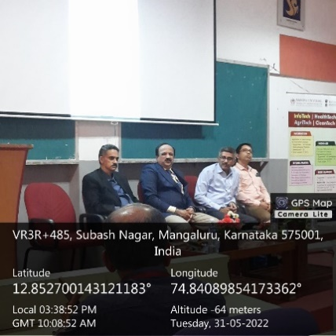 | 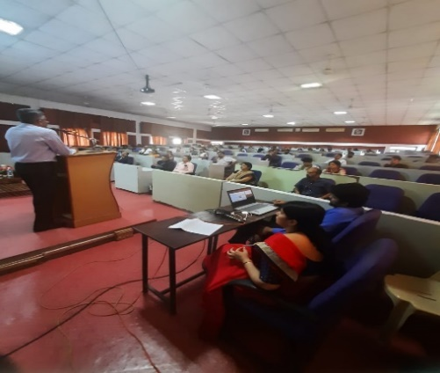 | 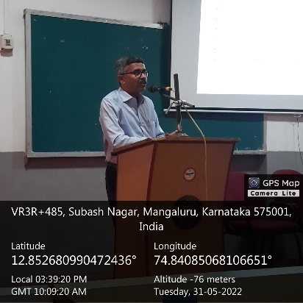

The following topics are addressed
- National Innovation and Start-up Policy 2019 for Students & Faculty
- NIDHI EIR scheme nurturing budding Entrepreneurs
- Institute Vs. Industry
- Introduction to Incubators
Around 40 faculties from various Colleges like Institute of Computer Science, Institute of Social Science and Institute of Hotel management participated in the Faculty Empowerment program. The participants interacted with the resource person to discuss about Entrepreneurship through Incubation centre for students.

National Level Paper Presentation Contest in Future Trends in ICCT and its Applications in IT, Management and Education by IEEE Srinivas University Student Branch in Association with IEEE Mangalore Subsection

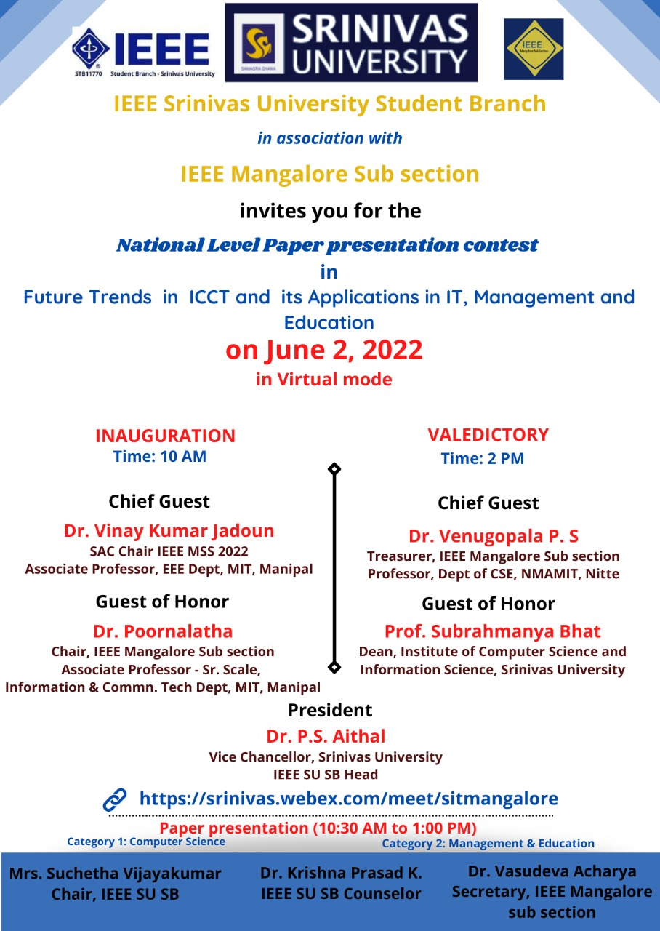In collaboration with the IEEE Mangalore subsection, the IEEE Srinivas University Student Branch organized the National Level Paper Contest for Ph.D. students on 02-06-2022 in virtual mode. About 50 research scholars have registered and submitted their scholarly articles. Among the articles received, 15 papers in two categories were presented. The virtual inauguration of the contest was done at 10 a.m. Dr. Vinay Kumar Jadoun, SAC Chair , IEEE Mangalore Subsection, Associate Professor, Dept of Electrical and Electronic Engineering, MIT Manipal, was the chief guest. In his address, he explained the importance of academic writing. “Scholarly writing is a part of the research. The researcher should get motivation from within. Research is not doing something new. Every researcher is adding some new concept to the existing work. This new thing is his contribution to the respective area.” Dr Poornalatha, Chair IEEE Mangalore Subsection was the guest of honor. in her address “scholarly writing increases the critical thinking of a researcher. To improve one’s skills paper presentations will help a lot.” The programme was presided over by Dr. P. S. Aithal, Vice-Chancellor, Srinivas University, Head, IEEE Srinivas University Student Branch. In his presidential address, Dr. P S Aithal said “There is huge scope for research in the development of new technologies. Advancement in technology has made our life easy. These days finding right information for our research is at our fingertips because of the advancement in technology. The quality of research improves only when we publish our work”.
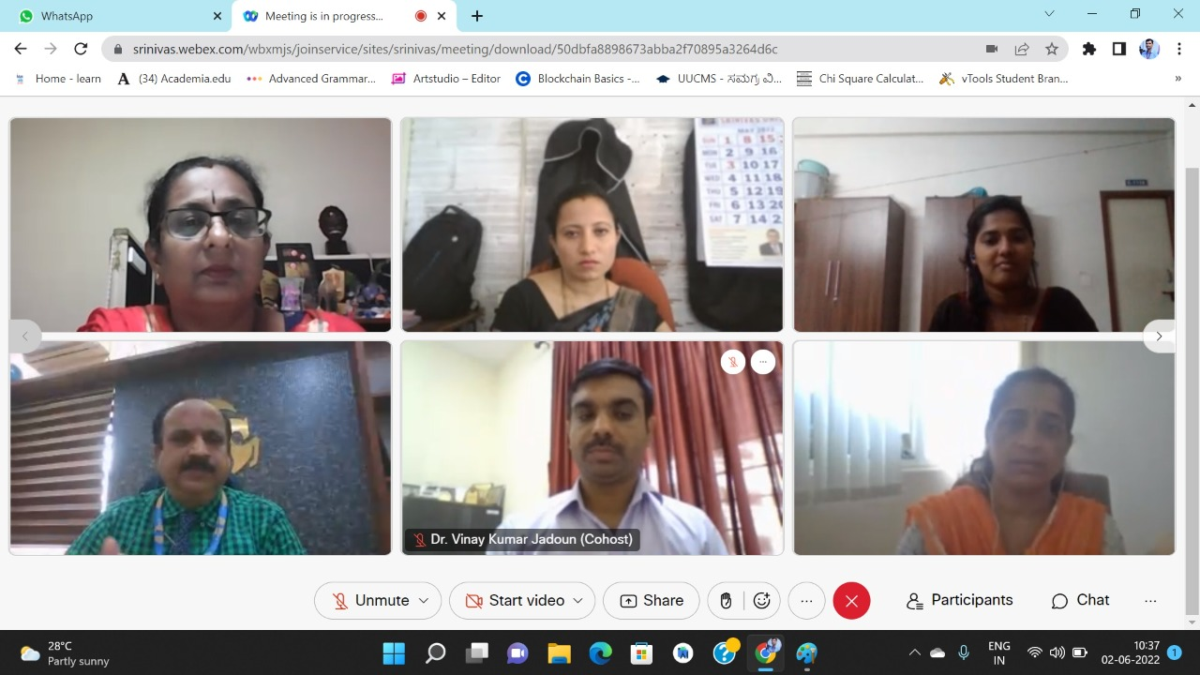
Dr. Krishna Prasad K, Counselor, IEEE Srinivas University Students Branch welcomed the guests and mentioned the objectives of the National Level Paper Contest. Mr. Vinayachandra, Vice-Chair, IEEE Srinivas University Students Branch proposed a vote of thanks. Mrs. Suchetha Vijaya Kumar., Chair, IEEE Srinivas University Student Branch compered the programme. Prof. Subrahmanya Bhat, Dean, Institute of Computer Science and Information Science, Srinivas University, present on the occasion. The program was attended by more than 60 research scholars. Dr. Annappa B, Professor, Dept of Computer Science and Engineering, NITK Suratkal, Dr. Jeevitha B K, Associate professor, Department of Computer Science and Engineering, Vivekananda College of Engineering and Technology, Puttur, Dr. Pallavi Mane, Professor, Dept of Electronics and Communication Engineering, MIT Manipal, and Dr. Sudhakar, Research Professor, Srinivas University participated as adjudicators for the paper contest.

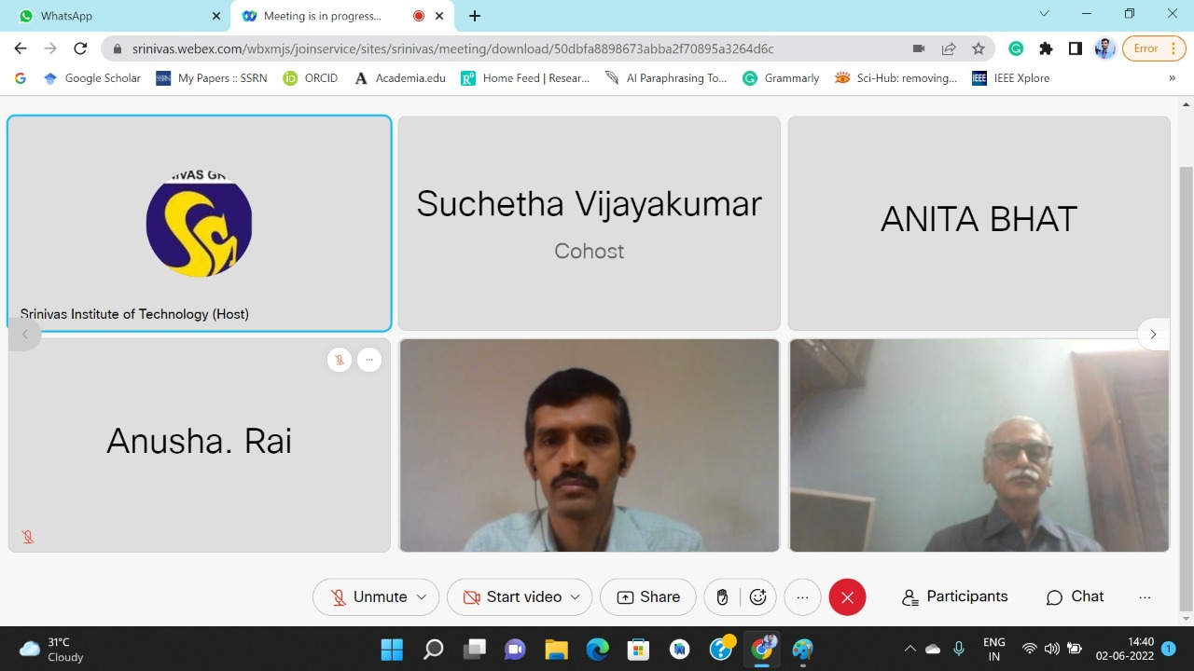
The valedictory programme of the National Level Paper contest was in virtual mode on 02-06-2022. Dr. Venugopal P S, Professor, Dept of Computer Science and Engineering were the Chief Guest. “Every paper published should contain some original work, The research paper will be there forever once it is published. Hence one must take utmost care in writing a research paper” he said in his valedictory address. Dr Srinivas Rao Kunte, Professor, Srinivas University, was guest of honour. In his address, he said “Research is a life-long process. Our original work will have a lot of value. Researcher should focus on learning and improving the work”. Dr. P. S. Aithal, Vice-Chancellor, Srinivas University, Head, IEEE Srinivas University Student Branch will be the president said that “Researchers should contribute something to the society. Participation in competitions will give a lot of experience to the research scholar. Every bit of information received in the form of suggestions by experienced researchers will be of great help for the improvement of research work.”
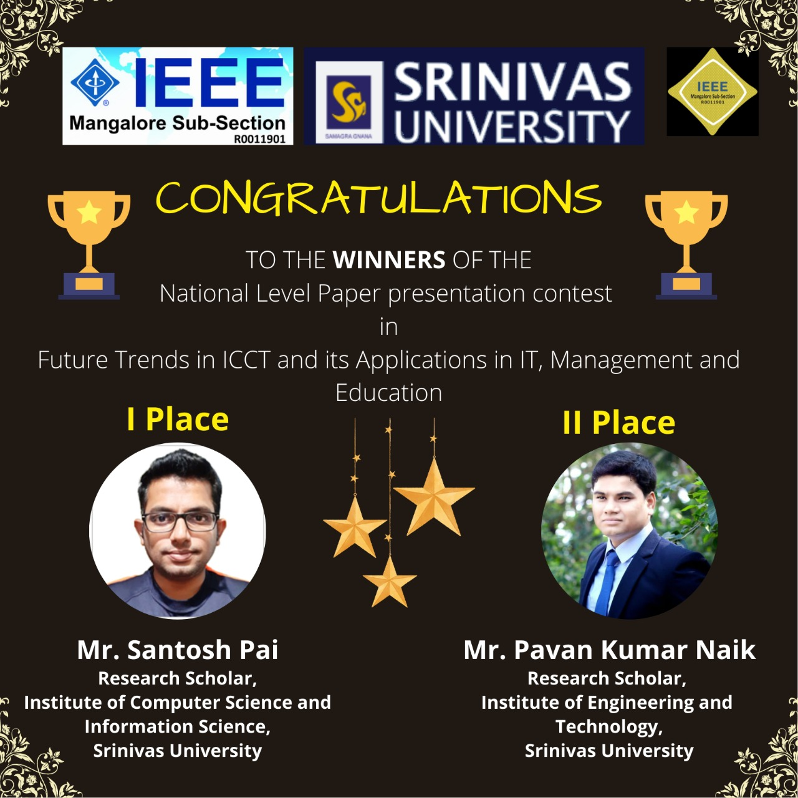
Mr Santhosh Pai, Research Scholar Institute of Computer Science and Information Science, Srinivas University, Mangaluru secured the best paper award for his research paper titled “Study of the Most Critical Security Vulnerability of the decade: Log4JShell” won the first place and Mr Pavan Kumar Naik, Research Scholar, Institute of Engineering and Technology won the second place for his paper titled “Importance of Identifying Γ-H2ax Foci In Nucleus Cell”. Dr. Krishna Prasad K, Counselor, IEEE Srinivas University Students Branch welcomed the guests Mr. Vinayachandra, Vice-Chair, IEEE Srinivas University Students Branch proposed a vote of thanks. Mrs. Suchetha Vijaya Kumar, Chair, IEEE Srinivas University Student Branch compered the programme. Professor Subrahmanya Bhat, Dean, Institute of Computer Science and Information Science, Srinivas University present on this occasion. The program was attended by 60 research scholars.
A Workshop on Quality teaching as a Prerequisite for Quality Learning by Dr. Jagadeesha S N, Research professor, Srinivas University
Institute of Computer Science and Information Sciences of Srinivas University conducted Five day Virtual Faculty development program on the topic “Quality Teaching as a Prerequisite For Quality Learning” from 1st June, 2022 to 6th June 2022.
Prof. (Dr). Jagadeesha S Research Professor, Srinivas University was the resource person. Prof. Dr. P S Aithal, Vice chancellor & Deans of all the colleges were also present.
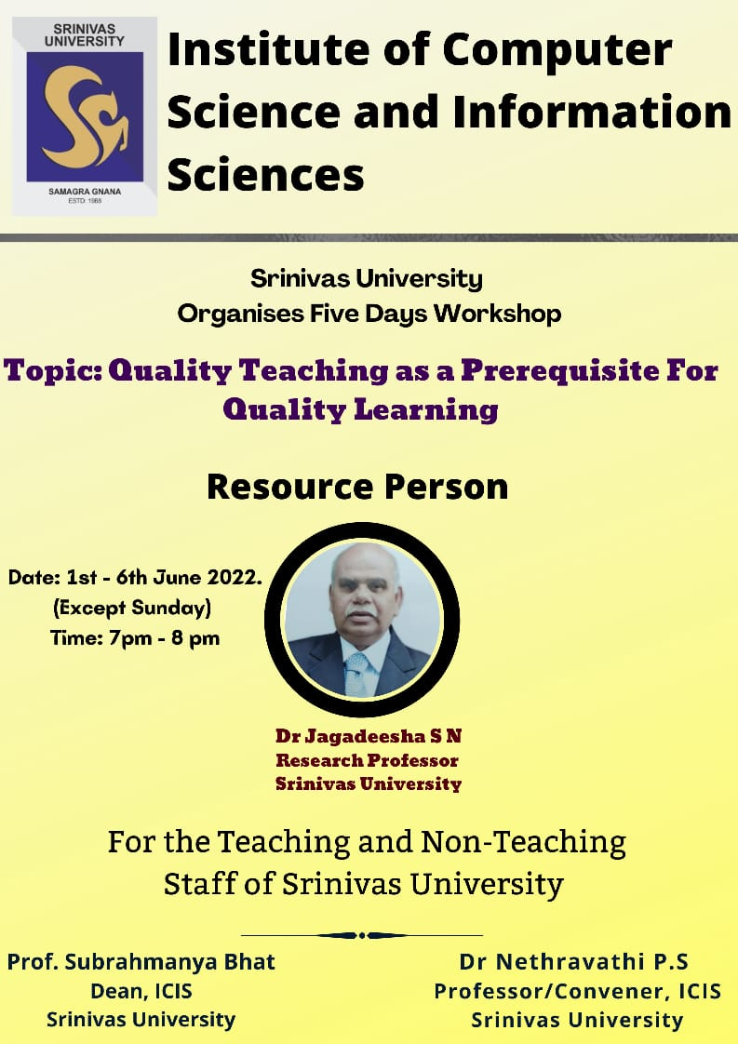

The following topics are addressed
- Quality Teaching and Research
- Enhancing the quality of quality of learning by improving the learning environment
- Participation of Students in Class
- problems faced by the research students

Around 80 faculties from various Colleges like Institute of Computer Science, Institute of Social Science and Institute of Hotel management participated in the Faculty development program. The participants interacted with the resource person to discuss Qualities of a good teacher problems faced by the research students. Dr.Nethravathi P.S, Professor of ICIS and convener of the program welcomed the resource person. Prof. Subramanya Bhat Dean of ICIS deliver the vote of thanks.

A Technical Talk on A Big Picture of NEP2020 by Prof. Dr. Karunakar Kotegar, Professor & Head, Department of Data Science and Computer Applications, MIT, Manipal
Institute of Computer Science and Information Sciences of Srinivas University conducted Faculty development program on the topic “The Big Picture of NEP2020”on 6th June, 2022.
Prof. Dr.Karunakar A Kotegar Head in the Department of Data Science and Computer Applications, Manipal Institute of Technology was the resource person. Prof. Dr. P S Aithal, Vice chancellor & Deans of all the colleges were also present. . Dr.Nethravathi P.S, Professor of ICIS and convener of the program welcomed the resource person. Prof. Subramanya Bhat Dean of ICIS deliver the vote of thanks.

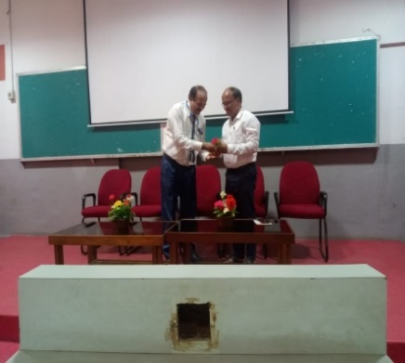 | 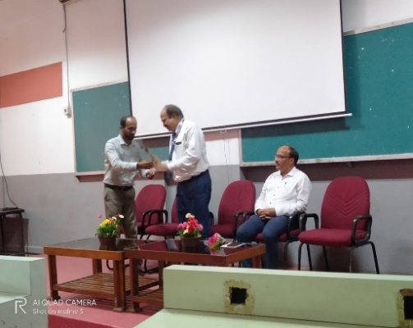 | 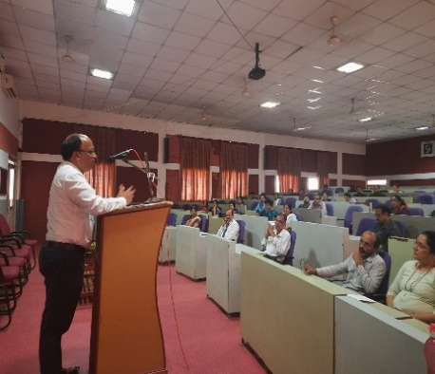

The following topics are addressed
- Early Childhood Care and Education: The Foundation of Learning
- The Vision of NEP
- Foundational Literacy and Numeracy: An Urgent & Necessary Prerequisite to Learning
- Curtailing Dropout Rates and Ensuring Universal Access to Education at All Levels
- Curriculum and Pedagogy in Schools: Learning Should be Holistic, Integrated, Enjoyable, and Engaging
- Empower students through flexibility in course choices
- Professional Standards for Teachers
- Promotion of Indian Languages, Arts, and Culture
- Quality Universities and Colleges: A New and Forward-looking Vision for India’s Higher Education System
Around 40 faculties from various Colleges like Institute of Computer Science, Institute of Social Science and Institute of Hotel management participated in the Faculty development program. The participants interacted with the resource person to discuss about Advantages and Disadvantages of implementing NEP in our University.
A webinar on IPR Awareness under AICTE-KAPILA NIPAM by Ramashish Paul, Examiner of Patents and Design, Intellectual Property office, Chennai, DPIIT, Ministry of Commerce and Industry.
IEEE Srinivas University Student Branch [STB11770] iin Association with Institute of Computer Science and Information Science of Srinivas University organized a Webinar on "IPR awareness under AICTE-KAPILA NIPAM" on June 07, 2022 at 3:00 PM by Mr. Ramashish Paul, Examiner of Patents and Design, Intellectual Property Office, Chennai, DPIIT, Ministry of Commerce & Industry. Mr. Ramashish Paul has a M. Tech in Molecular engineering from IIT Delhi. (2014-2016). He has done a project titled” Computational study of Selective Catalytic Reduction on several Metal oxides”. He has cleared National level Exams such as GATE AIR-190 in 2014 and CSIR-NET in 2012 & 2013.
Dr. P.S. Aithal, Vice chancellor and Prof. Subramanya Bhat, Dean of ICIS were present for the programme. Dr. Krishna Prasad K, Associate Professor of ICIS and Brach Counsellor, IEEE Srinivas University student branch welcomed the guest speaker. Mrs. Suchetha, Chair, IEEE Srinivas University student branch gave the vote of thanks. Around 50 Students, Research Scholars and IEEE members attended the webinar.

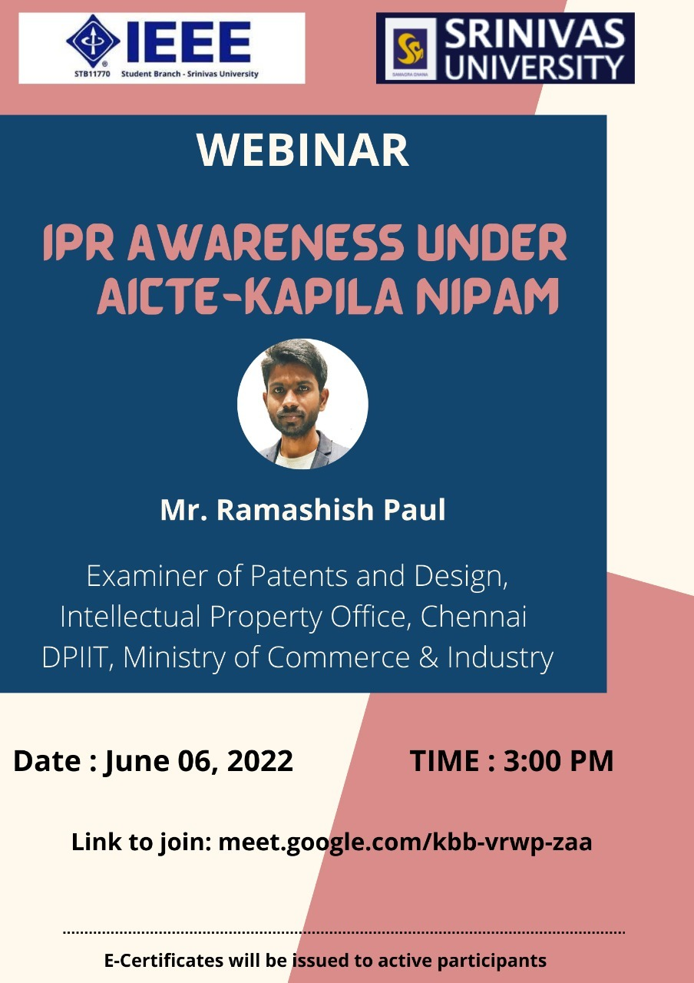
A Webinar on Sustainable Earth-Living in Harmony with Nature by Dr. Sara Kunnath, Academic Advisor, Koshy's Institute of Management Studies, Bangalore
Institute of Computer Science and Information Sciences of Srinivas University conducted Virtual Faculty development program on the topic “Sustainable earth- Living in harmony with Nature” on 13th June, 2022 .
Dr. Sara Kunnath Academic Advisor, Koshy’s Institute of Management studies, Bangalore was the resource person. Prof. Dr. P S Aithal, Vice chancellor & Prof. Subramanya Bhat Dean of ICIS were present.
Deans of all the colleges were also present.
The following topics are addressed
- How can we live sustainably with nature?
- Why is it important to live in harmony with nature and its beings?
- Buy fair trade products to support fair wages for farmers and a higher quality of products.
- Recycle and reuse whatever you can.

Around 60 faculties from various Colleges like Institute of Computer Science, Institute of Social Science and Institute of Hotel management participated in the Faculty development program. The participants interacted with the resource person to discuss “How can we live sustainably with nature? “.Dr.Nethravathi P.S, Professor of ICIS and convener of the program welcomed the resource person.

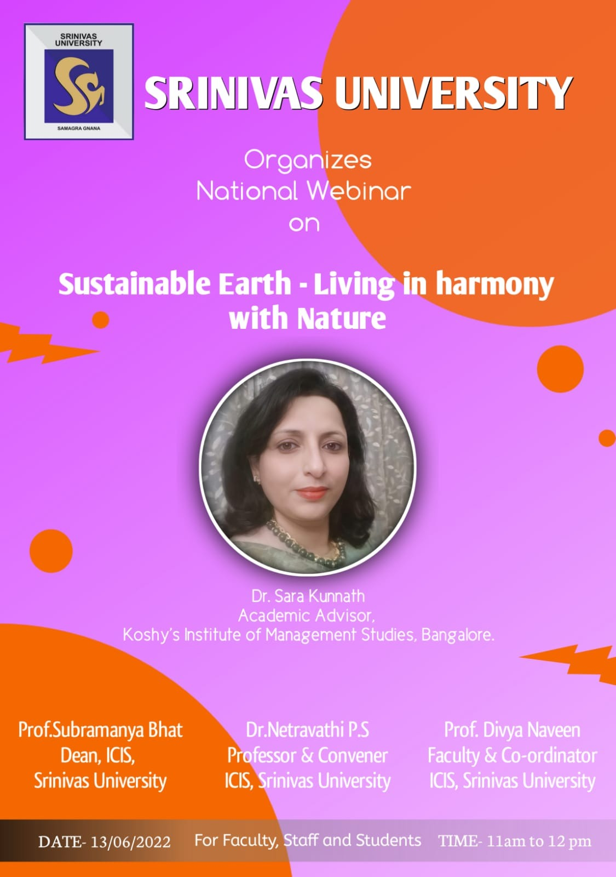
National Conference on Future and Innovation Technology in IT, Management & Education
NCFITM-2022
at Srinivas University, Mangaluru

NCFITM-2022 – One day National Conference was inaugurated vvirtuallyon 30th of June 2022, at 10 am at Srinivas University Pandeshwar Campus by Dr. K.E. Prakash, Principal & Director of Shree Devi Institute of Technology, Mangalore & Former Registrar at Visvesvaraya Technological University, Belagavi.
Shri CA. A Raghavendra Rao, Honorable Chancellor of Srinivas University and President of A. Shama Rao Foundation was the president of this function. Dr. A. Srinivas Rao, Pro-chancellor of Srinivas University and Vice-President of A.Shama Rao Foundation, Mangaluru was the guest of honour for the inauguration. Dr.P.S. Aithal, Vice chancellor of Srinivas University briefed about the conference and its importance.
After releasing the Research Abstract book, the chief guest Dr. K.E.Prakash said that, the title of the conference “Future and Innovation Technology in IT, Management, and Education” is very trendy because of the amount of knowledge and technology that are seen today in order to solve many challenges is enormous. The smartphones we carry in our pockets are more powerful devices than the olden supercomputers. He also mentioned that, how today's information technology has grown far beyond the simple use of computer systems and communications. He said that, IT is now regarded as the primary driver of global business expansion. Developers, software engineers, and IT experts are using cutting-edge technology to innovate industries, improve personal life tasks, and improve social life. At the end he congratulated the organizers for organizing this event and helping young researchers to think about new areas in IT and Management.

Pro-chancellor of the university Dr.Satya Sai Kumar was also present on the occasion. The international speakers Dr.Vishal Dattana, Faculty, Department of Computing, Middle East College, Muskat, Dr. Rajermani Thinakaran, a Senior Lecturer in the Faculty of Data Science and Information Technology (FDSIT) at the INTI International University, Nilai, Malaysia were present for the inauguration.
Soon after the inauguration, the first keynote session begun with the international speaker Dr.Vishal Dattana, Faculty, Department of Computing, Middle East College, Muskat on the topic “Industry 4.0 Why it Matters?”. The second session was taken by Dr. Rajermani Thinakaran, a Senior Lecturer in the Faculty of Data Science and Information Technology (FDSIT) at the INTI International University, Nilai, Malaysia on “Intelligent Tutoring System- A User Model”. The third session was delivered by Dr. P. S. Aithal, Vice-chancellor, Srinivas University on the topic “Emerging Trends in Computing & Networking to build Information Superhighways”. Around 150 research scholars and faculties from various colleges participated in this conference.
More than 50 research articles received from various research scholars. From 2 pm to 4 pm the researcher presented their work and it took place with two parallel sessions by the eminent research professors. Dr.Krishna Prasad K, Associate Professor of ICIS was the session chair for this presentation. Prof.Harshitha from ICIS rendered the invocation. The conference convener & the Professor of ICIS, Dr.Nethravathi P.S welcomed and introduced the guests to the gathering. Prof.Subramanya Bhat, Dean of ICIS gave the vote of thanks and Prof.Divya Naveen was the master of Ceremony for the inaugural function.
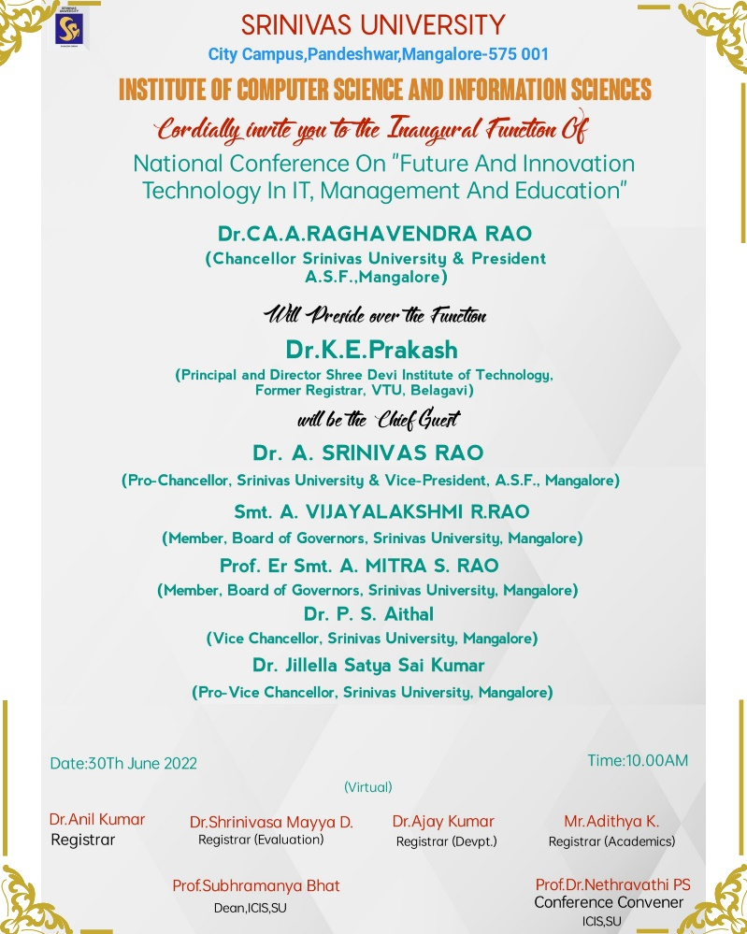
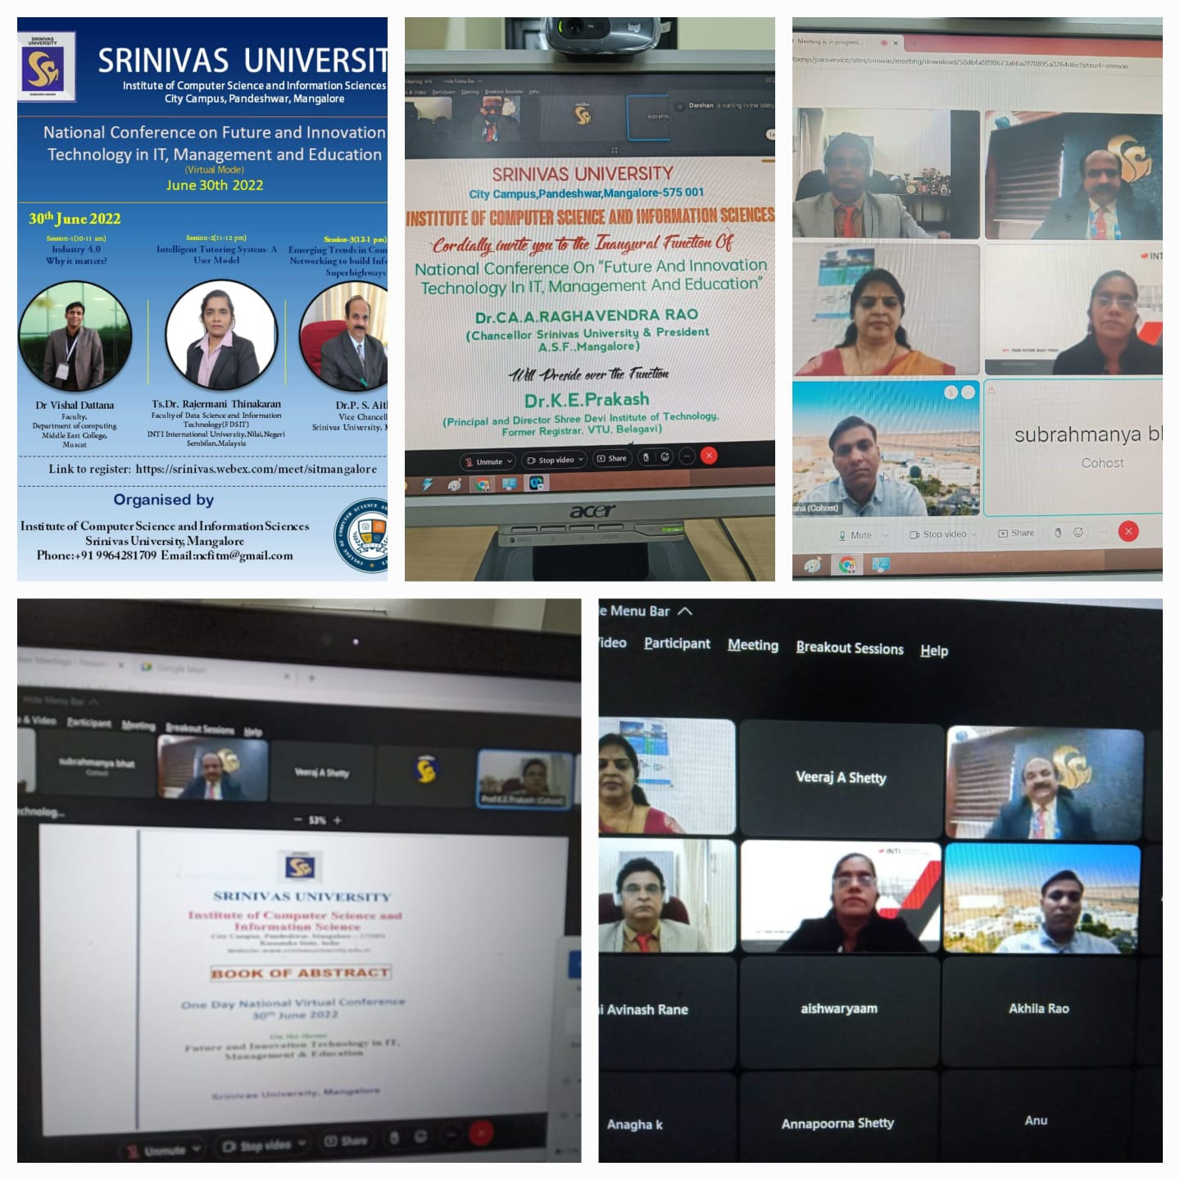

A technical Talk on How to build resume? a workshop conducted by Prof. Shwetha Pai, a soft skill trainer, Mangalore

Institute of Computer Science and Information Sciences of Srinivas University conducted A technical Talk on How to build resume?, a workshop conducted by Prof. Shwetha Pai, a soft skill trainer, Mangalore for all the MCA students on 13th June, 2022 . She trained student in building the right resume format and the layout. She mentioned that how they have to summaries their objective, including their language proficiency in technical programming and how to tailor their information according to the Job advertisements. Around 60 MCA students participated in the program. Dr. Nethravathi P.S, Professor of ICIS and convener of the program welcomed the resource person.
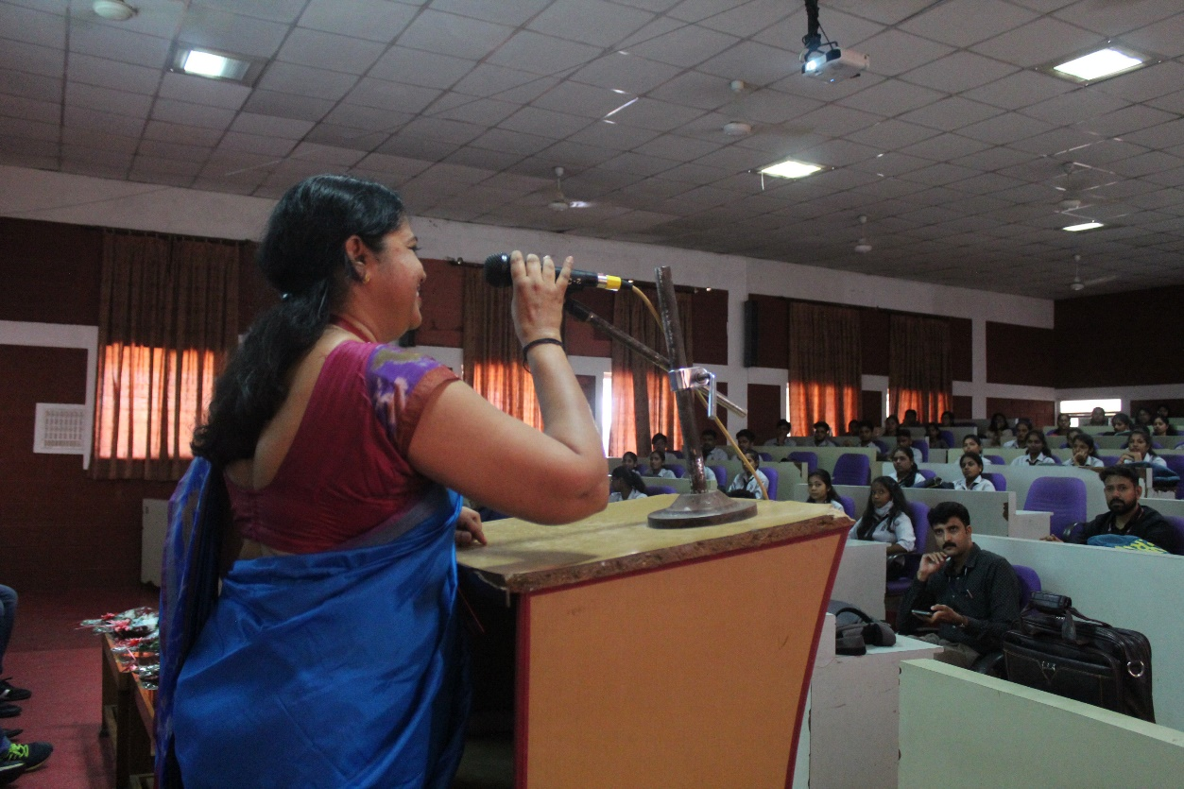

A Pre-placement Talk on How to crack the interview? a workshop conducted by Mr.Suhas Shetty, Managing Director of DevAppSys IT Solutions Pvt. Ltd., Mangalore

Institute of Computer Science and Information Sciences of Srinivas University conducted a Pre-placement Talk on How to crack the interview? a workshop conducted by Mr.Suhas Shetty, Managing Director of DevAppSys IT Solutions Pvt. Ltd., Mangalore. He guided students to maintain a good CGPA and to learn technical things according to their passion. He also told them to be very strong in technical fundamentals where most of the companies ask the basics with the students to test their foundation skills on technical. All the MCA post graduate students participated in this talk. Dr. Nethravathi P.S, Professor of ICIS and convener of the program welcomed the resource person.

